ALBANIA NATIONAL CERVICAL CANCER PROGRAM

EVALUATION REPORT OF THE FIRST YEAR
2020

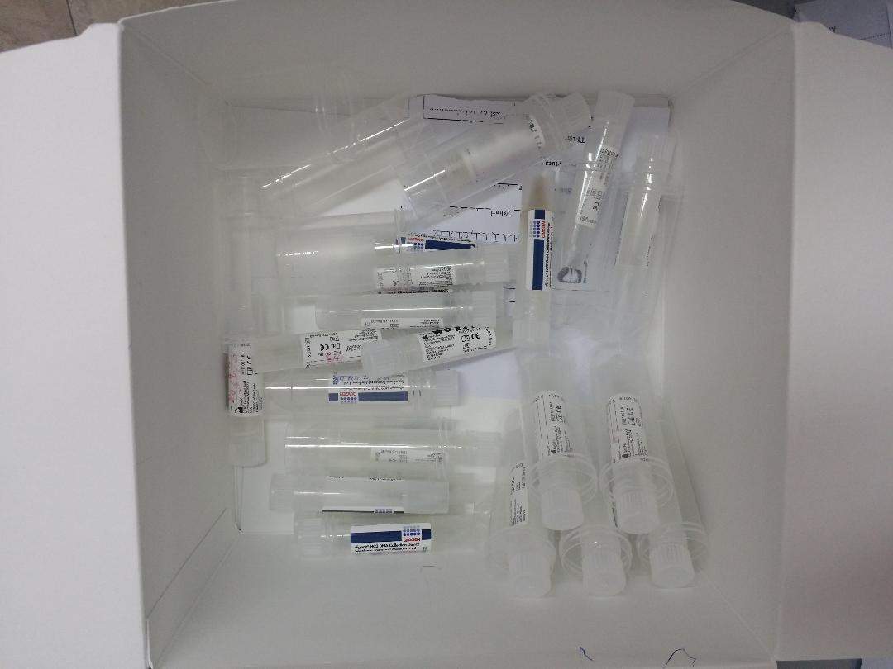

JANUARY 2020
This report is written by:
Alban Ylli
Kozeta Filipi
Lila Shundi
Albana Fico

With contributions from:
Mirela Rista, Anila Xhani, Silva Celiku, Bajram Dedja, Miranda Hajdini, Besjan Elezaj, Kreshnik Petrela and Majlinda Ikonomi

Special thanks go for the coordinators from local units of health care in selected districts. Without their professional work the evaluation of the program would have been impossible.
Amanda Cela | Shkoder
Alfa Peci | Elbasan
Enerta Habipaj | Berat
Nada Terpo | Korce
Anisa Meco | Lushnje
Vitore Haxhiu | Durres
Gezime Kormaku | Tirane
Adelina Kovaci | Tirane
Klementina Meco | Delvine
Jetmira Kera | Diber
Lida Ciko | Gjirokaster
Margarita Muka | Tepelene
Klementina Meco | Delvine

Dritan Roshi has helped with data management and Kreshnik Petrela worked on translating the report into Albanian and editing

SUMMARY OF FINDINGS
The National Cervical Cancer Screening Program (NCCSP) in Albania is based on the Decree of the Council of Ministers No. 47 (30.1.2019). NCCSP uses as primary screening examination the high risk HPV testing. The initial program targets women 40-50 years old. The goal is to provide within five years, all women in this age group, high risk Human Papilloma Virus (HPV) screening tests, as part of the routine examinations done at primary health care (PHC) centers. The screening program will improve identification of women who are at higher risk for cervical cancer, detect in time the pre-cancer lesions, and treat them accordingly. Under the new program, all primary screening tests and further examinations are to be provided free of charge at the point of care, regardless of the patients’ health insurance status.
On the basis of the technical framework of the NCCSP program, each health center physician refers women who have come out positive, to perform a diagnostic colposcopy to a qualified gynecologist and, when necessary, cytology or biopsy. The program allows for the diagnosis of pre-cancerous stages, their treatment and prevention of cervical cancer.
NCCSP follows a number of national health policies, including National Cancer Program, Non Communicable Diseases (NCD) Control Plan and Reproductive Health Strategy. It is also in line with the relevant international documents in the field.
During the period February-June 2019, 538 health professionals from around 400 health centers were trained all over the country to prepare the primary health centers and public health system for the NCCSP implementation.
As of 1st of December 2019, of around 13900 test kits distributed in health centers more than12300 samples were collected. At the IPH Molecular Biology Laboratory, almost all collected vaginal samples were tested and nominal responses distributed. Of the samples tested, 6.1% were positive for high-risk HPV (HR-HPV). During the month of December 2019, additional screening test kits were being distributed to health centers according to the needs
IPH coordinated all the program and provided technical expertise and logistical support when it was needed. At regional level the coordinators were responsible for local coordination and management; receiving test kits from IPH and distributing them to every health centre, then collecting the samples/information, to be sent to IPH, and delivering laboratory results to health centers. At PHC level the director and head nurse were key person for the program; they took care for all coordination of activities, from invitation of women to assuring the follow up. In some urban areas, personnel of women centers were very supportive for the program. Qualified gynecologists at Tirana University Hospitals provided reference clinical care for diagnoses and treatment of pre-cancers.
There has been an overrepresentation of rural women population in NCCSP. 58% of total participants live in rural areas. Similarly, the program has been used comparatively more by women with only basic education and those unemployed. It seems that screening program appeals more rural communities, where women are more interested for easier access to basic health services and collaborate better with health PHC personnel. A similar pattern is also observed at National check-up program for persons 35-70 years old.
Overall high risk HPV prevalence among participants in the program was 6.1%, while it was higher in urban populations of women, as well as among those with higher education, the employed and unmarried.
HPV positive women reported to have used more the pap-test services in the past, compared to HPV negatives. As HPV positive women are of a higher socio economic class and more urban, they may have been more frequent users of a health service, which is mostly opportunistic and with extra costs, Women of lower socio economic classes and those of rural areas, while have been showing lower HPV infection prevalence, were more inclined to use the national systematic screening program, attracted by the opportunity of its easy access and insignificant costs.
In Tirane, Vlore, Lezhe, Gramsh, Gjirokaster and Devoll the HPV prevalence was the highest. Has, Peqin, Permet, Malesi e Madhe, and Kukes, were municipalities with the lowest prevalence rate.
While partner’s circumcision was not associated to the odds of being infected with HPV, smoking seems to be a significant factor increasing its risk.
There were 6.5% of women participating in program, who were older or younger than the program target age category (40-49). Those women show a higher prevalence of HPV infection (7.1%). The perception about their higher risk may have contributed for the inclusion of these women in the program. Also, there were more than 5% of participating women, who had done the HPV test previously, and they should not have been invited for screening during 2019.
81% of participating HPV-positive women knew about prevention and 46% of them knew about HPV infection. In both cases the awareness rate increased with education.
The overwhelming majority of women interviewed reported to live within 20 minutes distance from the health centre. Still, for 33% of them, to go to the health centre could take 20 to 40 minutes.
Both physician and the nurse of the health center where involved in inviting and counseling women during primary screening. The majority of invitations were done by home visits and phone calls. Almost 80% of the women have received appropriate information during primary testing visit.
One in three women had asked the physician or midwife to help with vaginal sampling and younger women were more inclined to do so. Those who decided to take the sample themselves used the health centre toilet room for the procedure. Only a small minority preferred to do it at their homes, and then bring the sample back to facility as advised. The majority of women found the vaginal sampling procedure very simple (60%) and not at all painful (72%). Only 8% reported it to be difficult and no one said it was very painful.
The average time from the primary screening test to women receiving the result was 25 days. 96% of women received their results within the program promise of two months. 90% of women went for getting the result within 7 days from the moment of being contacted. All HPV-positive women surveyed went to health centre to receive the test result.
The average time of counseling at primary health care for positive women was around 20 minutes and only 6% of women reported to have been counseled insufficiently (5 minutes or less)
At the time of the survey, around 90% of HPV-positive women either had gone for follow up visit or were planning to go as soon as possible. Still about 10% of them were still reluctant to go. There don’t seem to be any substantial delay in receiving follow up care, with the totality of women going to gynecologist within one month from the moment they received the HPV test result. The average time was only 6 days
Screening program should try to keep all out-of-pocket costs at a minimum; the Albanian Government decree, upon which the program is delivered, underlines that all the services related to primary screening and follow up, at public sector are free of charge at the point of care. Health personnel have been trained to inform women about it, so to minimize all avoidable personal expenditure. Nevertheless, more than one in three women who have performed colposcopy, have chosen private healthcare for that. Additionally, 8% have gone abroad for the follow up examination, typically in Greece and Italy. The majority have done the colposcopy in Tirana’s university gynecological hospitals. Women with university education were more inclined to go for the follow up visit to a private facility and especially abroad.
The majority of gynecologists (68%) have recommended other tests during their follow up visit with half of positive women recommended cytology and 15% biopsy. The average time spent at gynecologists was 25 minutes. 4% of HPV-positive women reported results compatible with pre-cancer or cancer, 73% reported negative results after gynecologist’s visit. Others reported either problems non compatible with pre cancer, or were not sure about it. The frequency of pre-cancer or cancer reported by interviewed women was similar to the frequency identified in clinical registries in Tirana University Hospital.
87% of positive women reported substantial worries about the positive result.
Around 9 in 10 of women rated the overall service at PHC, as well as at specialized care ‘good’ or ‘very good’. The remaining of women considered it ‘average’ or ‘bad’.
METHODOLOGY OF THE EVALUATION
Desk review of burden of diseases and health policies, plans and guidelines about cervical cancer screening in Albania
To evaluate the compatibility of the NCCSP with international and national health policies in the field of cervical cancer control, a desk review of all relevant documents was carried out. More than 15 documents were reviewed about their position on regards of cervical screening plans and policies. In addition, all unpublished data from national death registry (INSTAT) and incidence cancer registry (IPH) were gathered and their analyses was carried out.
Screening program information system: Characteristics of users of the program
An individual form was developed by working group to be filled at primary health care center for each women participating in the program. GPs or nurses who contacted the women were responsible for filling it. The form accompanied the vaginal sample and was collected by IPH together with them. The forms were produced by IPH and distributed together with screening test kits to all health centers. Health care providing personnel was trained to fill the forms.
The system allowed analyzing the prevalence of high risk HPV infection in different categories of women tested, including age, residence, and some social strata. It gathered also data on reproductive characteristics and risk factors.
The instrument (form) is attached to this document as an annex
At the moment when evaluation analyses commenced, (November 18th 2019), around 12000 forms have been collected, and around 10000 forms have been computerized by trained members of the working group.
Data flow within the program information system
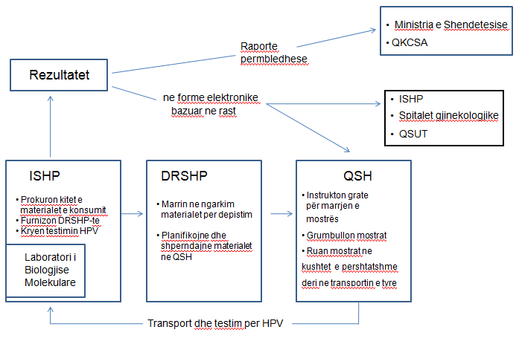
Methodology of the survey of HPV-positive women: their experience with the program at different levels of the health system
A detailed and structured questionnaire was prepared to evaluate all the issues related to women participating in the program and resulted positive in primary screening test; their experience in all the levels of the health system. At the end of the report, in annex 3 it is attached the instrument used to gather the data.
Among 37 health districts of the country, 10 districts were purposively selected for the sample to best represent the population. Local program coordinators were invited to participate and then trained on the questionnaire.
Around 20 women, who had resulted positive in primary screening tests for each district, were randomly selected from the information system of the screening program. There was a sample of around 200 women, who had participated in the program and resulted positive
Finally, as 23rd November 2019, there were 198 women who were reached and accepted to be interviewed about their program experience. These participants were from the original sample of 200 women who had resulted positive in primary screening test for Hr HPV, and represent a subsample of total population of women who participated in the program. 22 women, who couldn’t be found or refused to participate, were substituted with other women from the list.
Linking the hospital registries to screening program information system.
At two colposcopy clinics of University gynaecologic hospitals of Tirana two simple systems of clinical registry were created with support from two members of the working group. In the system there were registered basic data from women who underwent colposcopy: names, age, residence and results of examination.
A third simple registry is set up at Oncological service at University Hospital covering biopsies carried out and new cancers being diagnosed during 2019
The system is predicted to help in long term tracing final health outcome of women who participate in screening program and evaluation of pre-cancers or cancers rate being detected and successfully treated.
Data have been gathered from IPH specialists and are computerized. As November 7th 2019, there have been around 100 colposcopy examinations related to screening program, carried out in each of those two hospitals. The individual cases are being linked between two systems. Among those cases examined, there have been diagnosed two carcinomas, one pre-cancer (CIN3) and one CIN2.
Key informant interviews
Around 15 health professionals were interviewed at regional level and in Tirana using an unstructured guide. They were selected among program coordinators near regional units for health care and gynecologists at hospitals. One focus groups with local coordinators was also organized. The unstructured questions for key informants are attached in annex 4 of this report. The comments from key informant interviews and focus group are summarized in the results section.
Evaluation of National HPV Laboratory
Finally, a systematic analyses of all capacities and processes, related to functions within the NCCSP of the national HPV laboratory was carried out. The laboratory registry system and its work protocols were used for that, together with comments and opinions from laboratory specialists.
INTRODUCTION: HEALTH AND ECONOMIC BURDEN OF CERVICAL CANCER
Cervical cancer is one of the most common cancers among women around the world, with almost 600,000 new cases and over 300,000 deaths in 2018. The distribution of cervical cancer incidence and mortality reflects global disparities in access to health services; nearly 90% of deaths happening in low- and middle-income countries. Yet, it is a preventable disease, with effective prevention programs established, especially in high-income countries.
Main cause of cervical cancers is persistent or chronic infection from oncogenic human papilloma viruses, which is typically spread by sexual contact. Strategies of prevention for cervical cancer are based on vaccination, screening and treatment of pre-cancers lesions.
Cervical cancer in Albania is a public health problem. It is, with uterus cancer, the second most frequent cancer among women of reproductive age (15-49 years), below only to breast cancer, mainly due to its characteristic increase of risk at middle age. The sexual lifestyle trends among Albanians point to a potential increase of this cancer in the absence of preventative strategies. According to country official data, the average mortality rate of cervical cancer for the period 2013-2017 in Albania is 2.9/100,000 and the incidence rate for the year 2015 (the first year, the national cancer registry has started to operate) is 9.2/100,000 (National NCD report). The mortality/incidence ratio for cervical cancer in Albania is 32%. Its standardized incidence is lower compared to South East European countries but much higher than Eastern Mediterranean countries.

While in most EU countries mortality and incidence of cervical cancer are on decrease, in Albania time trends have not shown signs of decline, neither for incidence (University Hospital registry) nor for mortality indicators (INSTAT), demonstrating limited efects of traditional health services, which have been mostly based on small scale, episodic and oportunistic early detection.

Time trend mortality rate for cervical cancer in Albania (/100000)
INSTAT

Distribution of deaths in age groups (70+ and under 70)
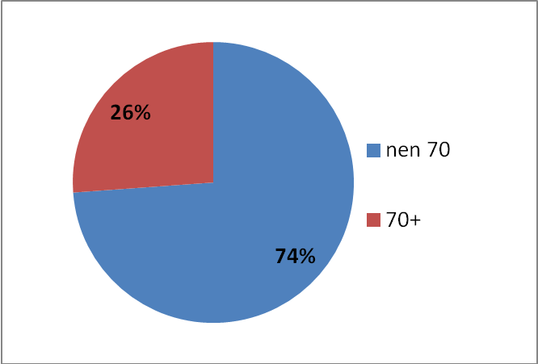
INSTAT
New cases of cervical cancer.
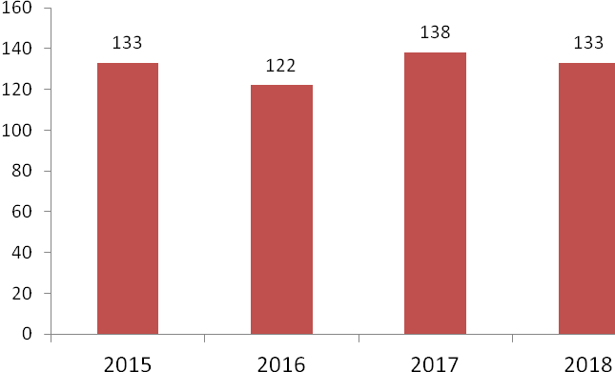
IPH
Cervical cancer risk reaches the highest incidence level at a relatively young age, compared to most cancers. In Albania the risk is highest at 40-49 years of age, declining afterwards.
Age distribution of incidence rate for cervical cancer in Albania* (/100000)
*Combined rate for the years 2014 and 2015. National Cancer Registry

Cost of Cervical cancer to Albanian Society
There is a great deal of potential for prevention, with prevention efforts expected to result in a number of healthy years of life. It is estimated that every year in Albania 2,000-3,000 healthy and productive life years are lost from cervical cancer related disease and death. In a conservative estimate, cervical cancer has costed Albanian society at least 5 000 000 US dollars yearly, because of productivity loss and health system related costs. Additionally, treatment to cervical cancer in Albania is estimated to cost, around 1 300 000 USD per year (cervical cancer treatment in countries with similar income to Albania costs between 8500 to 12 400 USD*)
Other, family and society related, long term costs, may add to those figures.

*Comprehensive global cervical cancer prevention. Costs and benefits of scaling up within a decade. Centre for health decision science. Harvard school of public health. 2016

ALIGNMENT OF CERVICAL CANCER SCREENING PROGRAM WITH INTERNATIONAL AND NATIONAL POLICY DOCUMENTS
There is a large international consensus about control of cervical cancer as a priority and cost effective intervention;
1. In September 2014m United Nations reviewed the achievements after 20 of ICPD in Cairo and reformulated a new action plan beyond 2014. In the field of health the ICPD +20 proposed specific interventions on reproductive tract cancers, especially breast and cervical cancer, by investing in routine screening at primary health care.
2. UN Global strategy for child and woman health (2010), and
3. Political declaration of UN General Assembly about non communicable diseases are two other international documents which support the interventions in prevention on cervical cancer.
4. Finally, the program of cancer screening in Albania is planned to contribute in achieving the sustainable development goal 3 ‘Ensure healthy lives and promote well-being for all at all ages’ and its specific targets:
3.7 By 2030, ensure universal access to sexual and reproductive health-care services, including for family planning, information and education, and the integration of reproductive health
3.8 By 2030, reduce by one third premature mortality from non-communicable diseases through prevention and treatment and promote mental health and well-being
h into national strategies and programs
5. WHO has developed a guide to essential practice about comprehensive cervical cancer control, its 2nd edition on 2014. WHO is also developing a global strategy for elimination of cervical cancer as a public health problem.
6. European Union has updated its guidelines on Quality Assurance on development cervical cancer screening tests in 2015.
The guidelines underline that “There is clear scientific evidence that a screening based on validated tests for the DNA of oncogenic HPV as primary test and applying an appropriate protocol is more effective than screening based on cytology in preventing invasive cancers of the uterine cervix. In addition, it entails a limited - if any - increase of the undesired effects both in terms of unneeded referral to diagnostic work-up and in terms of over-diagnosis and consequent overtreatment of spontaneously regressive lesions.”
Some other principles highlighted in the guidelines of both EU and WHO are:
- At least 5 year interval after negative test: the 5-year cumulative risk of high-grade CIN after a negative HPV test is lower than the 3-year risk after a normal cytology.
- HPV-based screening should not start before 30-35 years.
- Only tests for the DNA of oncogenic HPV, validated according to thebest standards.
- No double testing with cytology and HPV

The Albanian protocols are based on WHO guidelines and recommendations, as well as on the European Union Guide on cervical cancer screening by means of HPV test.
Cervical cancer early detection and screening is included in a number of national health policies of Albania.
1. The Law on reproductive health (No 8876, dt. 4.4.2002) doesn’t specifically mention cervical cancer, but in its articles 22 and 23 regulates the treatment of diseases of reproductive tract and include into services of reproductive health, activities of education, prevention, detection, treatment and follow up.
2. National Strategy of Health refers to National Plan for Cancer Control when mentioning screening for cervical cancer
3. National Plan of Cancer Control 2011-2020 has its objective 1 ‘the development of a national program aiming at reduction of breast and cervical cancer mortality’. More specifically, its intervention 5, under that objective underlines ‘screening, case management, and quality assurance of screening tests for breast and cervical cancer in primary health care and hospitals’.
4. In National program for prevention and control of NCD 2016-2020, cervical cancer is mentioned among main NCD priorities in the situation analyses section. Then the program recommends building on the existing check-up initiative system and ‘preparing the ground for the development of the cervical screening program in line with the National Cancer Control Action Plan’. The objective3.4 asks for integration of screening practices with all levels of health care, specifically mentioning ‘to pilot population-based cervical cancer screening for future expansion’ at the activity 3.4.4. The outcome measurement indicator 3.4.4: specifies ‘findings and recommendations from the pilot population-based cervical cancer screening are implemented’.

5. The strategic document and action plan for sexual and reproductive health 2017 2021 lists among major strategic objectives ‘prevention early detection and treatment of cancers of reproductive tract. The special section (1.5) dedicated to those cancers covers in its objective 2 ‘strengthening diagnostic capacities for cervical cancer management’ while activity 2 is about ‘development of screening protocols for cervical cancers’

6. Action plan of the health promotion strategy 2017-2021, covers also the control of cervical cancer in its objective 1.9 activity 2 ‘organization of national campaigns for raising awareness among women about breast and cervical cancer screening’.

7. The package of essential services at primary health care approved with a decree of council of ministers (no. 101, 4.2.2015), includes services related to early detection of cervical cancer.

8. On December 2016 Minister of health approved a full guideline and the related protocol dedicated exclusively to screening of cervical cancer at primary health care services. The aproval was not followed by imediate support.

Actions, policy reforms, towards the development of the national screening program: 2010-2019
Previous to 2010, interventions in the field of cervical cancer prevention were not systematic or sustainable. During the last decade, the efforts started to be better coordinated and integrated to national health policies. A number of health system based analyses, capacity building, awareness activities, policy development and guidelines preparation have been carried out by Ministry of Health (MoH), Institute of Public Health (IPH), University Hospitals (UH) in partnership with United Nations or European Union agencies.
A timeline of main developments during the last decade which culminated with the start of the National Screening Program
Timeline | Intervention, policy change, progress | Main Stakeholders and partners
2010 | International workshop on cancer screening in Albania. With participation of International Agency of research on cancer (IARC) experts. Recommendations on analyses and capacity building. | MoH, IAEA, WHO, UNFPA
2011 | First National Cancer Control Plan 2011-2020 developed and approved by an order of Minister of Health. | MoH, IAEA, WHO, UNFPA
2012 | First system analyses on breast and cervical cancer screening opportunities with support from UNFPA and European Association of Cervical Cancer Screening. | MoH, IPH, UNFPA
2013 | First national hospital-based study of capacities and gaps for cervical screening. A team of gynecology, cytology and public health professionals prepared a report after visiting all regional hospitals and interviewing a large sample of health professionals. | MoH, IPH, UH, UNFPA
2013 | IPH sends first technical document with specific recommendations on cervical cancer screening to MoH. | IPH
2014 | National technical workshop on comprehensive Cervical Cancer control.  Declaration of Wisdom signed by ministers, deputy ministers, members of parliament and other personalities of public life. The document underlined the need to do more to prevent cervical cancer and protect women’s life from this disease. | MoH, IPH, UH  UNFPA, WHO
2015 | Inter-institutional working group on guidelines of cervical cancer at Primary Health Care (PHC) level under leadership of IPH and Center for Quality on Heath Care (CQHC).  Guidelines and protocols for cervical cancer control at PHC approved by an order of Minister of Health on December 2016. | IPH, CQHC, UH, ACPD, UNFPA, WHO
2016 | TAIEX analyses on CC screening.  First accredited training course on cervical cancer screening practice at PHC level, based on guidelines and protocols  Small scale pilot program at 3 health centers in Tirana and Fieri. | MoH, IPH, EU, UNFPA
2017 | Organized Pilot program for cervical cancer screening in Fieri district in collaboration with specialized Italian and French Institutions. High risk HPV test used as a primary screening test. | IPH, UNFPA, CPO InCA, ACPD,
2018 | WHO technical mission on breast and cervical cancer screening  IPH develop the technical framework for a national screening program | WHO  IPH
2019 | National Program of cervical cancer screening approved by Government Law and financed by Ministry of Health and Social Protection (MHSP).  Capacity building and program organization at all levels starts by February.  Women 40-49 years old are offered free screening based on high risk HPV tests, at primary health care level. | MHSP, IPH, UNFPA, ACPD, WHO

Setting up the national program: 2019
Description of standard procedures and primary test results

At the end of January 2019, the Albanian government made the important decision to establish the first coordinated national screening program for cervical cancer in the country. The initial program targets women 40-50 years-old. The goal is to provide all women in this age group high risk HPV screening tests, as part of the routine examinations done at primary health care centers. The screening program is planned to improve identification of women who are at higher risk for cervical cancer, detect in time the pre-cancer lesions, and treat them accordingly. Under the new program, all primary screening tests and further examinations are to be provided for free at the point of care, regardless of the patients’ health insurance status.
To minimize the added workload every screening program brings about, nurses at PHC services are taking more responsibilities from general practitioners. In addition, screening tests based on self sampling, were considered very practical for women and guarantee minimal workload for health providers.

All the technical details of the program are described in ‘Technical Frame of National Screening Program’ developed by IPH.
This technical frame has served as a bases to develop a training course, and during the period February-June 2019, 538 health professionals from around 400 health centers are trained all over the country.

Personnel trained about the screening program
IPH 2019
REGION | PHYSICIANS | NURSES | TotAL
Tirana | 38 | 25 | 63
Shkodra | 23 | 15 | 38
Vlora | 22 | 15 | 37
Lushnja | 25 | 16 | 41
Berati | 25 | 17 | 42
Durresi | 23 | 16 | 39
Fieri | 23 | 15 | 38
elbasani | 21 | 14 | 35
Lezha | 25 | 16 | 41
Korça | 38 | 25 | 63
Kukësi | 22 | 15 | 38
Diber | 22 | 15 | 37
Gjirokastra | 34 | 23 | 57
Totali | 323 | 215 | 538

In co-operation with the local department of public health, a coordinator was assigned in each district to organize the distribution of kits to each health center, collecting samples and sending tests to the PHI. This person also dealt with the distribution of test results at each health center so that the relevant family physicians could inform women and make the appropriate recommendations depending on the test results.
In parallel with the training, the test kits and the set of accompanying information materials were distributed to each department of public health. Until July 2019, the distribution of the kits and accompanying other materials was completed throughout the country with the exception of a small reserve maintained at the PHI in order to adapt to the population's response to the program.
Along with the distribution of screening consumables and the delivery of trainings in each district, NCCSP begin to provide services; inviting women of the target population, conducting screening tests and sending samples for testing to PHI. As of 1st December 2019, of all total kits distributed in health centers, more than12300 were collected. At IPH Molecular Biology Laboratory, there were tested almost all collected vaginal samples. Out of all the samples tested, 6.1% were positive for high-risk HPV (HR-HPV) and this would constitute the prevalence of positivity for this category tested.
For all samples analyzed in the laboratory, a personalized response was sent to the Local Health Care Units, which then delivered the results to each health center.
Results of HPV samples collected and analyzed

district | NR. OF DISTRIBUTED TESTS | NR. OF COLLECTED samples | NR. OF HPV TESTed samples | NR. OF POSITIVE CASES
Tirana | 3000 | 2458 | 2385 | 211
Shkodra | 1150 | 1085 | 1072 | 60
Vlora | 650 | 638 | 638 | 54
Lushnja | 600 | 580 | 578 | 31
Berati | 750 | 728 | 724 | 27
Durresi | 1350 | 1278 | 1274 | 77
Fieri | 1050 | 963 | 957 | 55
elbasani | 1550 | 1422 | 1414 | 67
Lezha | 700 | 646 | 644 | 45
Korça | 1150 | 994 | 991 | 57
Kukësi | 550 | 477 | 473 | 15
Diber | 750 | 699 | 696 | 25
Gjirokastra | 650 | 368 | 279 | 15
Total | 13.900 | 12.337 | 12.125 | 739
IPH. National HPV screening laboratory. 1 December 2019

On the basis of the technical framework of the program, each health center physician counsels women who have come out positive to perform a diagnostic colposcopy, to a qualified gynecologist and, where necessary, cytology or biopsy. The program allows for the diagnosis of pre-cancerous stages, their treatment and prevention of cervical cancer. In a sample of 100 colposcopies in HPV-positive women performed at two Tirana university hospitals (in the frame of NCCSP), there were identified two carcinomas, one pre-cancer (CIN3) and one CIN2 (4% CIN2+ lesions).
RESULTS FROM THE INFORMATION SYSTEM OF THE SCREENING PROGRAM.
Data about women participating in program
As November 23, there were 10002 cases entered in program database. As the system is manual, it takes time to computerize forms which come to national laboratory along with vaginal samples from primary health care centers. The completion of information system is delayed relative to laboratory real time work. This explains the difference between the number of tests carried out in laboratory (around 13000) and the cases in program database (around 10000).
Nevertheless, the sample is large enough to allow robust conclusions about HPV+ prevalence in different demographic, geographic, and social categories.
There were few missing data regarding to the HPV test result. Other missing data are reported at the tables.
Prevalence of HPV positives, according to demographic and geographic characteristics
Total high risk HPV prevalence in this sample was 6.2%. It doesn’t change much if calculated for 13000 cases already tested in laboratory (6.1%).
6.5% of women who participated in program fall outside the program target age category (40-49). Women from this category show a higher prevalence of HPV infection. For both categories under and over the program age limits the prevalence is 7.1%. (Table 1.1) The perception about this higher risk may have contributed for the inclusion of these women in the program.
As the program during the year 2019 was focused on age groups 44-45 and 48-49, those two age groups are reflected as the most represented among program participants with 80% of them falling in these two age categories. Still, there are women of other age groups invited in the first year of the program and this has contributed to lowering of the targeted screening coverage for this year. (Figure 1.1)
HPV prevalence is significantly higher in urban populations of women (6.9%) compared to rural areas (4.7%), confirming the increasing of risk for infection with a potentially intensification of urbanization in the future in Albania. (Table 1.2)
Table 1.1 Prevalence of Hr HPV. Age-group distribution
 | HPV+ | HPV + % | HPV - | Total | Total %
35-39 | 18 | 7.8 | 213 | 231 | 2.3%
40-49 | 570 | 6.2 | 8744 | 9314 | 93.5%
50-55 | 28 | 6.7 | 387 | 415 | 4.2%
Total | 616 | 6.2% | 9344 | 10002 | 100.0%

Table 1.2 Prevalence of Hr HPV. Urban Rural distribution
 | HPV+ | HPV + % | HPV - | Total | Total%
Rural | 265 | 4.7 | 5423 | 5688 | 57.5%
Urban | 299 | 6.9 | 4015 | 4314 | 42.5%
Total | 613 | 6.2 | 9271 | 10002 | 100.0%

Figure 1.1. Age distribution of women participants in the program
Age groups (years)

There is no age difference among two categories of HPV positives and HPV negatives. Although there are variations in nominal age groups (Figure 1.2), both mean ages among HPV positives and negatives are 46 years old. (Table 2)
Table 2. Mean age of HPV positive and HPV negative categories
 | Totali | HPV+ | HPV-
Mean age (years) | 46.4 | 46.2 | 46.4

Figure 1.2. Age distribution of HPV+ prevalence rate (%)
Age in years
Hr HPV prevalence %
Table 3 shows HPV positive prevalence rate among all districts of the country. In Tirane, Vlore Lezhe, Gramsh Gjirokaster and Devoll the HPV prevalence is the highest. Has, Peqin, Permet, Malesi e Madhe, and Kukes, are municipalities with the lowest prevalence rate.
Table 3. Distribution of HPV + prevalence according to municipalities
Municipality | HPV+ cases | HPV +  % | HPV – cases | Total  cases | Total  %
Berat | 17 | 3.4 | 488 | 505 | 5.1
Devoll | 5 | 10.6 | 42 | 47 | 0.5
Durrës | 44 | 5.7 | 724 | 768 | 7.8
Elbasan | 34 | 4.0 | 806 | 840 | 8.5
Fier | 35 | 5.7 | 583 | 618 | 6.3
Gjirokastër | 5 | 8.9 | 51 | 56 | 0.6
Gramsh | 12 | 8.6 | 127 | 139 | 1.4
Has | 1 | 1.1 | 88 | 89 | 0.9
Kavaje | 19 | 7.6 | 231 | 250 | 2.5
Korçë | 21 | 4.8 | 421 | 442 | 4.5
Kruje | 22 | 7.8 | 259 | 281 | 2.8
Kuçovë | 5 | 3.8 | 125 | 130 | 1.3
Kukës | 5 | 2.7 | 177 | 182 | 1.8
Kurbin | 4 | 4.7 | 81 | 85 | 0.9
Lezhe | 28 | 8.5 | 303 | 331 | 3.3
Librazhd | 7 | 4.5 | 148 | 155 | 1.6
Lushnje | 27 | 5.1 | 499 | 526 | 5.3
M.Madhe | 3 | 2.2 | 133 | 136 | 1.4
Mallakaster | 7 | 5.9 | 111 | 118 | 1.2
Mat | 7 | 3.2 | 213 | 220 | 2.2
Mirditë | 7 | 6.5 | 101 | 108 | 1.1
Përmet | 2 | 1.4 | 146 | 148 | 1.5
Peqin | 0 | 0.0 | 54 | 54 | 0.5
Pogradec | 22 | 7.0 | 291 | 313 | 3.2
Puke | 5 | 5.7 | 83 | 88 | 0.9
Shkodër | 18 | 5.0 | 344 | 362 | 3.7
Skrapar | 3 | 5.5 | 52 | 55 | 0.6
Tepelenë | 4 | 8.9 | 41 | 45 | 0.5
Tiranë | 184 | 9.0 | 1857 | 2041 | 20.6
Tropojë | 3 | 3.7 | 79 | 82 | 0.8
Vau i dejes | 9 | 7.3 | 115 | 124 | 1.3
Vlorë | 48 | 8.8 | 498 | 546 | 5.5
Total | 613 | 6.2 | 9271 | 9884 | 100.0

Social caracteristics of HPV positive and HPV negative women
In tables 4.1-4.4 HPV positive and HPV negative cases are distributed according to certain social characteristics. They serve to identify social differences between HPV infected and those who are not infected.
There are less married women among HPV positives compared to HPV negatives. Under the category ‘other’ are included unmarried women, divorced or separated, those cohabitating with a partner etc. (Table 4.1)
Table 4.2 is an alternative way of analyzing the association of place of residence to the risk of being infected with high risk HPV, already explored above in the table 1.2. The urban-rural profile is very different between two groups, HPV positives and HPV negatives. The majority of women infected with HPV live in cities (52.5%), while only 41.2% of women without HPV infection live in cities. The majority of HPV negatives (58.2%) live in countryside. To be noted that there is an overrepresentation of rural women population in the program. 57.5% of total participants live in rural areas, while in Albania the population living in urban areas is larger. It seems that screening program works better with rural communities, where women collaborate better with health personnel of primary health care.
When analyzing distribution of education categories of women in total sample, it is observed a slight overrepresentation in the program of women with only basic education (8 years school) while the women with university education (more than secondary education) are underrepresented. This analysis is based on comparing program education category proportions with those reported by ADHS 2018 (women 15-49 years old: no school 4%, primary 35%, secondary 34%, more than secondary 26%). When comparing education categories between HPV positives and HPV negatives in the sample, it is noted that there is a higher probability for HPV positives to have higher education than HPV negative women.
A similar profile is observed also when analysing association of employment with being HPV positive. There are more employed women among HPV positives and more unemployed among HPV negatives. Again, the distrubution of the total sample into employement categories shows that the unemployed are overrepresented in the program compared to general population, reflecting probably the rural overrepresentation, described above.
Table 4.1. Civil status
 | Total  cases | Total  % | HPV+ cases | HPV +  % | HPV – cases | HPV-  %
Other | 817 | 8.2% | 87 | 14.1% | 730 | 7.8%
Married | 9185 | 91.8% | 529 | 85.9% | 8656 | 92.2%
Total | 10002 | 100% | 616 | 100% | 9386 | 100%

Table 4.2. Residence
 | Total  cases | Total  % | HPV+ cases | HPV +  % | HPV – cases | HPV-  %
Rural | 5675 | 56.7% | 325 | 52.8% | 5350 | 57.0%
Urban | 4327 | 43.3% | 291 | 47.2% | 4036 | 43.0%
Total | 10002 | 100% | 616 | 100% | 9386 | 100%

Table 4.3. Education
 | Total  cases | Total  % | HPV+ cases | HPV +  % | HPV – cases | HPV-  %
Not primary | 31 | 0.3% | 3 | 0.5% | 28 | 0.3%
Primary | 4419 | 44.2% | 234 | 38.0% | 4185 | 44.6%
High school | 3302 | 33.0% | 223 | 36.2% | 3079 | 32.8%
University | 1901 | 19.0% | 138 | 22.4% | 1763 | 18.8%
No answer | 349 | 3.5% | 18 | 2.9% | 331 | 3.5%
Total | 10002 | 100% | 616 | 100% | 9386 | 100%

Table 4.4. Employment
 | Total  cases | Total  % | HPV+ cases | HPV +  % | HPV – cases | HPV-  %
Employed | 4247 | 42.5% | 302 | 49.0% | 3945 | 42.0%
Not employed | 5167 | 51.7% | 282 | 45.8% | 4885 | 52.0%
No answer | 588 | 5.9% | 32 | 5.2% | 556 | 5.9%
Total | 10002 | 100% | 616 | 100% | 9386 | 100%

Reproductive life of HPV positive and HPV negative women
Women positive in high risk HPV screening test, have slight differences compared to other, HPV negative women, when a range of reproductive life indicators are analyzed.
Mean age of first pregnancy is identical for both groups of women, while mean age of first sex is slightly different, with HPV positives entering their sexual life only 3 months earlier.
Average number of births is similar in two groups, but there are comparatively more HPV positive women with only one birth or none births at all, while HPV negative women are more likely to have had 2 and more births.
Conversely, average number of abortions is slightly higher among HPV positives, especially when the categories of women who had 2 and more aborts are compared.
Table 5. 1. Reproductive behaviour indicators in HPV+ and HPV- women
 | Whole sample of women participating in the program | HPV+ | HPV-
Mean age of  first sex | 20.8 years | 20.5 years | 20.8 years
Mean age of first pregnancy | 22.7 years | 22.7 years | 22.7 years
Average number of births | 2.8 births | 2.7 births | 2.8 births
Average number of aborts | 1.6 aborts | 1.7 aborts | 1.6 aborts

Table 5.2. Reproductive behaviour differences in HPV+ and HPV- women
 | Whole sample of women participating in the program |  |  | HPV+ |  | HPV-
 | Nr of cases | Nr of cases in % |  | Nr of cases | Nr of cases in % | Nr of cases | Nr of cases in %
Age of first sex
13- 17 years | 686 |  | 6.9% | 55 | 8.9% | 631 | 6.7%
18-22 years | 6688 |  | 66.9% | 410 | 66.6% | 6278 | 66.9%
≥23 years | 2029 |  | 20.3% | 107 | 17.4% | 1922 | 20.5%
No answer | 599 |  | 6.0% | 44 | 7.1% | 555 | 5.9%
Age of first pregnancy
14-18 years | 418 |  | 4.2% | 27 | 4.4% | 391 | 4.2%
19-22 years | 4716 |  | 47.2% | 289 | 46.9% | 4427 | 47.2%
23-27 years | 3427 |  | 34.3% | 192 | 31.2% | 3235 | 34.5%
over 28 years | 757 |  | 7.6% | 49 | 8.0% | 708 | 7.5%
No answer | 684 |  | 6.8% | 59 | 9.6% | 625 | 6.7%
Number of births
0 | 610 |  | 6.1% | 55 | 8.9% | 555 | 5.9%
1 | 599 |  | 6.0% | 56 | 9.1% | 543 | 5.8%
2 | 3901 |  | 39.0% | 227 | 36.9% | 3674 | 39.1%
3 | 2905 |  | 29.0% | 171 | 27.8% | 2734 | 29.1%
4 | 1196 |  | 12.0% | 58 | 9.4% | 1138 | 12.1%
More than 4 | 791 |  | 7.9% | 49 | 8.0% | 742 | 7.9%
Number of aborts
0 or no answer | 7246 |  | 72.4% | 432 | 70.1% | 6814 | 72.6%
1 | 1612 |  | 16.1% | 97 | 15.7% | 1515 | 16.1%
2 | 782 |  | 7.8% | 57 | 9.3% | 725 | 7.7%
3 | 234 |  | 2.3% | 18 | 2.9% | 216 | 2.3%
More than 3 | 128 |  | 1.3% | 12 | 1.9% | 116 | 1.2%

Distribution of selected factors related to cervical cancer
While circumcision of partner can be considered a protective factor against infection from HPV, many studies have identified smoking as an independent risk factor for cervical cancer. In the standardized form used during primary screening test there were included fields covering these two characteristics. Smoking included not only regular but also occasional smoking.
Results of the analyses are presented in the table 6. While partner’s circumcision is not associated to the risk of being infected with HPV, smoking seems to be a significant factor increasing the odds for it. There are more than 20% of HPV positive women who have reported to smoke, when the prevalence of smoking among HPV negatives was reported to be only 16%.
Table 6. Factors related to cervical cancer risk
 | Total |  | HPV+ |  | HPV-
 | Nr of cases | Nr of cases in % | Nr of cases | Nr of cases in % | Nr of cases | Nr of cases in %
Partner circumcised
Yes | 3054 | 30.5% | 186 | 30.2% | 2868 | 30.6%
No | 6317 | 63.2% | 385 | 62.5% | 5932 | 63.2%
No answer | 631 | 6.3% | 45 | 7.3% | 586 | 6.2%
Any smoking
Yes | 1623 | 16.2% | 124 | 20.1% | 1499 | 16.0%
No | 7781 | 77.8% | 454 | 73.7% | 7327 | 78.1%
No answer | 598 | 6.0% | 38 | 6.2% | 560 | 6.0%

Use of preventive services
Previous use of preventive health services was explored to identify any difference among HPV positive and HPV negative women as well as long term health seeking behavior of women in the target population.
There were around one in five women participating in the program who had done at least one pap-test in the past (Table 7). This figure may represent the overall population rate (in this age) of utilization of pap-test opportunistic screening services. HPV positive women were more inclined to use the pap-test services in the past with almost 24% of them falling in this category. The proportion of HPV negative women who had done pap-test in the past was smaller at only 20%. (Table 7).
Potential explanation for this difference can be the fact that, as showed above in this section, HPV positive women are of a higher socio economic class and more urban. These factors may have driven their better utilization of a health service which is mostly opportunistic and associated with substantial out of pocket costs, especially logistic ones. Women of lower socio economic classes and those in rural areas, while have been showing lower HPV infection prevalence, were more inclined to use the national systematic screening program, attracted by the lower barriers; easy access and insignificant costs.
Table 7. Pap tests in the past
 | Total |  | HPV+ |  | HPV-
 | Nr of cases | Nr of cases in % | Nr of cases | Nr of cases in % | Nr of cases | Nr of cases in %
yes | 2052 | 20.5% | 145 | 23.5% | 1907 | 20.3%
no | 7950 | 79.5% | 471 | 76.5% | 7479 | 79.7%

RESULTS FROM THE EVALUATION SURVEY IN A SAMPLE OF HR HPV POSITIVE WOMEN
Socio demographic characteristics of the sample and prevention awareness
There were 198 women who were reached and accepted to be interviewed about their program experience. These participants are from the original sample of 200 women who had resulted positive in primary screening test for Hr HPV, and represent a subsample of total population of women who participated in the program. 22 women who couldn’t be found or refused to participate were substituted with other women from the list.
In the table 8 is presented the sample distributed by its main socio-demographic strata.
11% of participants fall outside the program target age category. This proportion is higher than that observed in total population of women participating in the program (6%).
The majority of women were married, 8% divorced, and 5% widowed. Only 4% were unmarried.
Comparing the education profile of women in the evaluation sample with that reported by Albanian Demographic Survey 2018, is a good way to estimate any eventual overrepresentation of certain education categories. In this sample of HPV positive women, selected from program participants, the education profile was very similar with that of total population of women of reproductive age in Albania. ADHS 2018 women 15-49 years old: no school 4%, primary 35%, secondary 34%, more than secondary 26%. Interestingly, this sample of around 200 Hr HPV positive women is more similar to general population in terms of education than the general sample of women participating in the program.
Over 30% of women were unemployed. Women working in public sector and those working in private businesses are presented at almost equal proportions (28% and 29%).
13% of participants answered yes to the question exploring about any other diseases they may have been diagnosed. This figure is similar to self-reported prevalence of any non communicable disease (11.5%) presented by ADHS 2018. It is only 1.5% higher than that and this may reflect the mean older age of the sample in evaluation survey.
Table 8. Socio demographic characteristics of the sample.
(Hr HPV positive women participating in the program)
 | Cases | Proportion
Age groups
<40 | 9 | 5%
40-44 | 71 | 37%
45-49 | 106 | 52%
>50 | 11 | 6%
Total | 198 | 100%
Civil status
Unmarried | 8 | 4%
Married | 165 | 85%
Divorced | 16 | 8%
Widowed | 9 | 5%
Total | 198 | 100%
Education
No school | 5 | 3%
Primary | 74 | 38%
High school | 65 | 34%
University | 54 | 25%
Total | 198 | 100%
Employment
Employed public | 57 | 29%
Employed private | 56 | 28%
Work at home | 25 | 13%
Unemployed | 60 | 31%
Total | 198 | 100%
Chronic diseases
Yes | 26 | 13%
No | 167 | 87%
Total | 193 | 100%

Women in survey were asked if they knew about cervical cancer prevention and HPV before primary screening test and if they had done a gynecological examination in the past (Tables 9.1 and 9.2)
There were 81% of women who knew about prevention and only 46% who knew about HPV infection. In both cases the awareness rate increases with education. The awareness rate about pap-test in ADHS 2018 was 75%, and the small difference can be explained by an older mean age of this evaluation survey sample. ADHS 2019 didn’t include HPV awareness and past gynecological examination
Table 9.1. Awareness about cervical cancer prevention (distributed in education categories)
Education | Yes (cases) | No (cases) | Yes (%)
Primary school | 55 | 26 | 68%
High school | 53 | 8 | 87%
University | 51 | 4 | 93%
Total | 159 | 38 | 81%

Table 9.2. Awareness about HPV infection (distributed in education categories)
Education | Yes (cases) | No (cases) | Yes (%)
Education | 24 | 55 | 30%
Primary school | 21 | 37 | 36%
High school | 42 | 12 | 78%
University | 87 | 104 | 46%

Around three fourths of women interviewed had done a gynecologic cervix examination (including cervical cancer examinations such as taking a vaginal smear for pap-test) in the past. This finding is similar to the rate found in a reproductive age population based survey in Fier (unpublished 2017). 25% of them had never done an examination or a test. (Table 9.3) There is not influence of education in this health seeking behavior.
In the program protocols, and in the instructions during the training sessions when preparing the screening program, it was recommended not to invite for HPV testing women who had done a similar test in previous 5 years. Nonetheless, there were 14 women or 7% of the respondents, who did fall into this category and most likely they had done the test within the last five years.
Table 9.3. At least one previous gynecological examinations (distributed in education categories)
Education | Yes (cases) | No (cases) | Yes (%)
Education | 57 | 22 | 72%
Primary school | 47 | 11 | 81%
High school | 42 | 12 | 78%
University | 146 | 45 | 76%

Figure 2.1 Awareness about prevention and education of women

Figure 2.2 Awareness about HPV infection and education of women
Experiences of women during the first contact to screening services
The distance from health facility where the primary screening is taking place, can be a barrier for many healthy women who are invited to participate in the program.
The overwhelming majority of women interviewed reported to live within 20 minutes distance from the health centre. Still, for 33% of them, the distance to the health centre could take 20 to 40 minutes. (Table 10)
Table 10. Distance from Health Centre
Distance in minutes | Cases | %
<10 min | 37 | 19%
10 to 20 min | 96 | 49%
20 to 40 min | 58 | 29%
>40 min | 7 | 4%
Total | 198 | 100%

Both physician and the nurse of the health center where equally involved in inviting women for screening. (Table 11.1)
In NCCSP there was not used a mailed invitation letter, as it was considered impractical for the conditions of the country. A frequent way of getting informed was during a visit to health centre often after learning about the service in TV or during Check-up program (national program of essential health control for persons 35-70 years old) visits. Another frequent way was by home visits. To be noted also that home visits by a nurse remain a very frequent way of working with women in primary health care in Albania. Telephone was also used in 20% of the cases. Rarely (3% of cases) a family member was contacted first. Using visits to the centre for inviting women to the screening program raises the concern of opportunistic screening and missing non users of health care (Table 11.2)
Table 11.1. Who informed women about screening
 | Cases | %
Physician | 86 | 44%
Nurse | 101 | 51%
Both | 11 | 5%
Total | 198 | 100%

Table 11.2. How women were invited for screening
 | Cases | %
Telephone | 39 | 20%
Home visit | 66 | 34%
During a visit | 88 | 45%
Family member | 5 | 3%
Total | 198 | 100%

After women were invited/informed about the program, there don’t seem to be significant delays in visiting health centre for screening. The average time was 4 days only. One fourth of women reported to come to screening within the day, and half of them used the service within 5 days. Around 20% have come to health centre within 10 days. (Table 12).
Table 12. Days to go to screening since receiving the invitation
 | Cases | %
Within one day | 49 | 24%
2-5 days | 96 | 49%
6-10 days | 43 | 21%
11-14 days | 12 | 6%
Total | 193 | 100%
Average delay 4 days

As it was the case of inviting women for screening, the counseling during the visit was performed by either the general practitioner or by the nurse. In one fourth of the cases both of them were involved in the counseling practice. (Table 13).
Table 13. Who performed the counseling at health centre
 | Cases | %
Only GP | 79 | 38%
GP and nurse | 46 | 26%
Only nurse | 74 | 36%
Total | 193 | 100%

Health professionals should spend enough time for counseling women, among other things, how to take vaginal sample so that to minimize the errors. The average time spent for counseling at the first contact with invited women is 15 minutes, and after the vaginal sample is taken was 11 minutes. It seems to be sufficient for the amount of information to be shared. Still, in a substantial number of cases it lasted only 5 minutes or less. (Table 14.1)
Almost 80% of the women have received information on both issues; how to get the vaginal sample, and the importance of the screening test. (Table 14.2)
In 5% of the cases women were informed only about the importance of the test, but these were cases when the sample was taken by a health professional (gynecologist or midwife).
Table 14.1. Length of counseling before and after taking the vaginal sample for the screening test
Before |  |  | After
5 min | 15 | 8% | 52 | 27%
10 min | 80 | 41% | 81 | 41%
15 min | 34 | 16% | 32 | 16%
20 min | 46 | 24% | 22 | 12%
30+ | 22 | 12% | 8 | 4%
Total | 197 | 100% | 197 | 100%
 | Average 15 min |  | Average 11 min

Table 14.2. Issues discussed during counseling
 | Cases | %
How to get vaginal sample (only) | 35 | 18%
Why is this test important (only) | 10 | 5%
Both | 151 | 77%
Total | 196 | 100%

The primary screening test technology used in the program allows women to take the vaginal sample themselves in their privacy. The pilot implementation of the screening model in Fieri region during 2017 showed that this approach was by far the most preferred way by women. It was also considered very important for rural health centers where there are not gynecological beds or not trained physicians or midwifes to perform the procedure. Still, in some cases women may want the doctor to perform the procedure. 33% of women in the sample reported to have asked the physician to help them with it. (Table 15.1) Younger women have been more inclined to ask the personnel to get the vaginal sample. (Figure 3).

Among the women who decided to take the sample themselves, the majority, or 106 of them, used the health centre toilet room for the procedure. Only a small minority (17 women), preferred to do it at their homes, and then bring the sample back to facility as advised (Table 15.2). 91% of those who took sample at home sent it back to facility within the day (result not shown).
Table 15.1. Requested assistance from doctor or midwife to get the vaginal sample
 | Cases | %
Yes | 66 | 33%
No | 132 | 67%
Total | 197 | 100%

Figure 3. Requested assistance to get the vaginal sample in age-group categories
Table 15.2. Where was taken the sample
 | Cases | %
HC room | 68 | 35%
HC toilet | 109 | 54%
Home | 21 | 10%
Total | 198 | 100%

The majority of women found the vaginal sampling procedure very simple (60%) and not at all painful (72%). Around one third of them consider it only somehow simple and somehow painful. 8% of them reported it to be difficult. No one said it was very painful. (Tables 16.1 and 16.2)
Table 16.1. How simple was vaginal sampling procedure

 | Cases | %
Very simple | 119 | 60%
Somehow | 65 | 32%
Dificult | 14 | 8%
Total | 198 | 100%

Table 16.2. How painful was vaginal sampling procedure
 | Cases | %
Not at all painful | 141 | 73%
Somehow | 56 | 27%
Total | 198 | 100%

The overall rating of the service at primary health care centre, by women who have used it, is ‘good’ or ‘very good’ (Table 17). Only 11% of women consider it average or bad (respectively 7% and 4%)
Table 17. Overall rate of the primary screening service
 | Cases | %
1 (bad) | 7 | 4%
2-3 (average) | 13 | 7%
4 (good) | 101 | 51%
5 (very good) | 76 | 39%
Total | 198 | 100%

Experiences of women during the delivery of screening test results
The program assured that individual vaginal samples were collected by Public Health departments (newly transformed into local units of health care) at every region and transported periodically at national laboratory at Institute of Public Health for testing. Then the test results were sent back in closed individual envelopes to health centers (again through regional Public Health departments). The average time from the primary screening test to women receiving the answer from health professionals was 25 days. 96% of women received their results within the program promise of two months. (Table 18)
Table 18. Time passed from the screening test to receiving the answer from health professionals
 | Cases | %
2 weeks | 54 | 26%
Within one month | 110 | 57%
Within 2 months | 25 | 13%
More than 2 months | 7 | 4%
Total | 196 | 100%
Average 25 days

Differently from the first invitation of women to the screening program, the most frequent way to deliver the test results was a telephone call. Home visits were still used in 18% of the cases, while visits at health facility only in 13% of the cases. (Table 19.1)
There were not significant delays or barriers related to the time passed from the moment being contacted to the moment going to health facility to get the result and further advice about it. Not a single women among those interviewed missed the second visit to the health centre. The majority (57%) of them went to the doctor within the day and one third went within the week. Less than 5% did that after two weeks. (Table 19.2)
Table 19.1. Ways of contacting women to inform about test results
 | Cases | %
Telephone | 133 | 68%
Home visit | 36 | 18%
Visit at HC | 26 | 13%
Family member | 3 | 2%
Total | 198 | 100%

Table 19.2. Time delay to go to health centre after being contacted about the test result
 | Cases | %
1 day | 111 | 57%
2-7 days | 65 | 33%
8-14 days | 12 | 6%
More than 14 | 8 | 4%
Total | 198 | 100%

Average time spent by physician to inform Hr HPV positive women on test results and advice about further examinations was 19 minutes. (Table 20.1) As expected, it is longer than time spent during the primary test visit. The majority of women (62%) reported to be consulted for more than 20 minutes by their physicians. Again, in 6% of the cases, the time seems to be insufficient with only 5 minutes spent. (Table 20.2) This fact is reflected also in the similar proportion of women who reported that information given to them by health professionals was insufficient. (Table 20.3)
Table 20.1. Time spent for telling results and counseling about further procedures
 | Cases | %
5 min | 12 | 6%
10-15 min | 63 | 32%
20-30 min | 100 | 51%
over 30 min | 22 | 11%
Total | 197 | 100%
Average time 19 min

Table 20.2. Counseling and specific recommendations at primary screening visit
 | Cases | %
To go for colposcopy | 127 | 24%
Info about HPV infection | 114 | 22%
Where to go for colposcopy | 74 | 14%
Info about coploscopy | 91 | 17%
Info about gynecological lesions | 55 | 11%
The right of intimacy | 60 | 12%
Missing data | 2 | 0%
More than one answer given by respondents

Table 20.3. The information after receiving positive result being sufficient or not
 | Cases | %
Sufficient | 184 | 93%
Not sufficient | 14 | 7%
Total | 198 | 100%

HPV infection is indeed basically a sexually transmitted infection, but usually can’t be successfully controlled in the same way other sexually transmitted infections are addressed. In addition, stigma about it, and the perceived lack of privacy about information related to positivity, can seriously prevent women to participate in a HPV based screening program. Women may feel guilty about it, while believing their partners will be suspicious and not supportive.
Health providers in the Albanian screening program had been recommended not to request positive women to share that information with their partners or other persons, if they didn’t want to. Hence, while the majority of positive women have nonetheless, talked about the infection with a relative, almost one fourth of have opted not to share that fact. (Table 21.1) The majority (60%) of those who have shared the information have done so with their partners; 20% with their parents and another 20% with a friend. (Table 21.2)
Table 21.1. Sharing Information about positive result
 | Cases | %
Yes | 152 | 77%
No | 45 | 23%
Total | 197 | 100%

Table 22.2 Person with who information about infection is shared
 | cases | %
husband | 99 | 60%
parents | 25 | 20%
friends | 26 | 20%
Total | 150 | 100%

Being identified as Hr HPV infected, doesn’t mean the woman has any cancer, or will have cancer. It won’t happen to more than 90% of them, but nonetheless, it substantially increases the women’s risk of getting cancer later in life. The screening program should make all the efforts not to induce unnecessary worry or anxiety about the disease to Hr HPV positive, but otherwise healthy women. Despite that, only a small minority (13%) of positive women reported not to have worries about their health related to the result of screening. (Table 22.1) The level of worry is generally very high and almost half of women reported it to be the highest possible. (Table 22.2)
22.1. Worried about the result
 | Cases | %
Yes | 172 | 87%
No | 26 | 13%
Total | 198 | 100%

22.2. Rate worries
 | Cases | %
1-little | 4 | 3%
2 | 12 | 8%
3 | 35 | 21%
4 | 34 | 20%
5-very much | 87 | 47%
Total | 167 | 100%

Women experience with follow up examination visits
One of the most crucial elements of the screening program is assuring that almost all Hr HPV positive women go for the coloposcopy at a specialized gynecology clinic. This examination is recommended by clinical algorithm of the program. The related performance indicator is the proportion of women who had gone for colposcopy among women who have resulted positive in primary screening test. Program should aim this indicator to be at least 90%, although is preferable it to be close to 100%. The indicator cannot be calculated based only on public hospitals information, as many women can still prefer to go to private clinics or abroad.
At the time of the survey, only 72% of Hr HPV positive women participating in evaluation survey, reported to have already carried out the colposcopy examination. (Table 23.1) The result can be considered satisfying as 66% of those who have not gone yet at the gynecologist, were planning to go there as soon as possible. When taking into account also a small number of women, who have done only a pap test after the primary screening, in total there are more than 90% of women who have done, or are planning to do soon, the follow up examination. 1 woman reported to have done cervical ultrasound as a follow up examination.
There is a lot of work still needed, to get closer to the 100% indicator, as there were more than 8% of women who have not followed the general practitioner recommendation, and were not planning to do so in the near future. (Table 23.2). Main reasons for that were: being too busy (6 women), being scared about it (5 women), not knowing where exactly to go (2 women), specialized care being very far (2 women), and considering the follow up health care expensive (only 1 woman). It seems that most of these issues could be addressed by a combined effort of primary health care and public health personnel.
Table 23.1. Women went for the colposcopy examination
 | Cases | %
Yes | 142 | 72%
No | 56 | 28%
Total | 198 | 100%

Table 23.2. Reason for not doing coloposcopy examination
 | Cases | %
Will go ASAP | 37 | 66%
Too busy | 6 | 11%
Don’t know where | 2 | 4%
Very far | 2 | 4%
Expensive | 1 | 2%
Fear | 5 | 9%
Did pap-test | 2 | 4%
Did ultrasound | 1 | 2%
Total | 56 | 100%

Screening program should try to keep all out of pocket costs at a minimum, while the decree of Albanian Government, upon which the program is developed, underlines that all the services related to primary screening and follow up, at public sector are free of charge at the point of care. Health personnel have been trained to inform women about it, so to minimize all avoidable personal expenditure. Nevertheless, more than one in three women (35%) who have performed colposcopy have chosen private healthcare for that. A significant proportion, (8%) have gone abroad for the follow up examination, typically in Greece and Italy. The majority (42%) have done the colposcopy in Tirana’s university gynecological hospitals. (Table 24).
Women with university education were more inclined to go for the follow up visit to a private facility and especially abroad. (Figure 4)
Table 24. Where was colposcopy performed
 | Cases | %
Tirana Koco Gliozheni | 27 | 19%
Tirana Geraldina | 32 | 23%
Regional hospital | 33 | 23%
Private hospital | 39 | 27%
Abroad | 11 | 8%
Total | 142 | 100%

Figure 4. Colposcopy clinic and education
There don’t seem to be any substantial delay in receiving follow up care, with the totality of women going to gynecologist within one month from the moment they received the HPV test result. The average time was only 6 days. The overwhelming majority or 74% of women went to colposcopy examination within one week. (Table 25)
Table 25. Time from recommendation to colposcopy
 | Cases | %
1 day | 23 | 17%
2-7 days | 81 | 57%
8-14 days | 27 | 19%
15-30 days | 11 | 7%
Total | 142 | 100%
Average 6 days

Table 26 describes the issues included in the counseling at follow up examination, typically given by a gynecologist. Most of them reflect the results of the examinations and individual counseling needs of the patients based on specialist’s clinical judgment. Yet, recommendation for long term follow up should have been provided to all Hr HPV positive women, while it was only for 64% of them. According the program protocol, they need to be re-checked within three years. Losing Hr HPV positive women, who resulted negative in colposcopy from long term systematic follow up can jeopardize the effectiveness of the program and should be addressed at both levels: primary health care general practitioners and hospital gynecologists.

Table 26. Counseling at follow up examination
 | Cases | %
Recommended follow up | 91 | 61%
Cervical lesions | 68 | 26%
Pre cancer and cancer | 48 | 18%
Where to go for other examinations | 71 | 27%
Long term monitoring | 55 | 21%
Costs of tests | 16 | 6%
Pap test | 8 | 3%
There was more than one answer given by respondents

In addition, the majority of gynecologists who had advised about periodicity of long term follow up seem to apply a more frequent than necessary standard (in protocol is stated that Hr HPV positive women who resulted negative in colposcopy are advised to do a another visit within 3 years); 42% of them have asked women to come for a check-up within 3 or 6 months, and another 49% within one year. (table 27)
Table 27. Time for follow up
 | Cases | %
3-6 months | 38 | 42%
12 months | 45 | 49%
24 months | 5 | 5%
36 months | 2 | 2%
60 months | 1 | 1%

A substantial majority of gynecologists (68%) have recommended other tests during their follow up visit. (Table 28.1) 66 women (47% of all 142 cases who have done colposcopy) report to have been recommended pap-test; 23 women (16% of all 142 cases who have done colposcopy) were recommended biopsy and 13 women (9% of all 142 cases who have done colposcopy) were recommended another HPV test. (Table 28.2) While the rate of pap-test and biopsy recommendations seems only relatively excessive, the extra HPV testing, which can be done only at private clinics and at high cost for women, can be considered scientifically doubtful and probably unnecessary. Further research is recommended on this issue
Table 28.1 Gynecologist recommended other tests
 | Cases | %
Yes | 92 | 68%
no | 40 | 30%
Total* | 132 | 100
There are 10 missing data

Table 28.2 Tests recommended by gynecologist during follow up visit
 | Cases | %*
Cytology | 66 | 47%
Another HPV test | 13 | 8%
Biopsy | 23 | 15%
Vaginal culture | 6 | 4%
Ultrasound | 4 | 3%
More than one test could have been recommended
*over all those who have done colposcopy (142 women)

One third of women, who went to gynecologist, reported the visit to have lasted less than 15 minutes. 56% of them reported a visit length of 20-30 minutes while for 11% of them it went for more than 35 minutes. (Table 29.1)
The waiting time before the gynecological visit also ranged from 5 minutes to 40 plus minutes, with the majority (88%) of women reporting to have waited for less than 30 minutes. (Table 29.2)
Table 29.1. Time spent during the examination by gynecologists
 | Cases | %
5-15 min | 43 | 33%
20-30 min | 74 | 56%
35-45 min | 9 | 7%
60 min | 5 | 4%
Total* | 131 | 100%
*11 missing

Table 29.2. Time spent waiting before examination
 | Cases | %
5-15 min | 82 | 62%
20-30 min | 34 | 26%
40+ min | 15 | 11%
Total* | 131 | 100%
*11 missing

Only 17% haven’t done yet the other tests recommended by gynecologist but most of them reported planning to go there soon. All recommended biopsies have been done, but not all cytologies. Only 2 women considered cost as a barrier for further examinations. One planed to go abroad (Greece). (Tables 30.1-3)
Table 30.1. Did other examinations recommended by gynecologogist
 | Cases | %
Yes | 76 | 83%
No | 16 | 17%
Total* | 92 | 100
*only those who have been recommended other tests by gynecologist

Table 30.2. Which tests recommended by gynecologogist were done
Did following tests | Cases | %
Paptest/cytology | 47 | 54%
Another HPV test | 13 | 15%
Biopsy | 23 | 26%
Ultrasound | 4 | 5%
More than one test could have been done

Table 30.3. Reasons for not doing tests
 | Cases | %
Will go ASAP | 13 | 81%
Very expensive | 2 | 13%
Planing to go abroad | 1 | 6%
Total* | 16 | 100%
*Only those who haven’t done other recommended tests.

In more than 40% of the cases gynecologists have recommended a treatment, which consisted in antibiotics, antimycotics, and other treatment for the infection. (Tables 31.1-2) The methodology doesn’t allow further inquiries about any over prescription of antibiotics among Hr HPV positive women.
Table 31.1. Gynecologists recommended treatment

 | Cases | %
Yes | 57 | 41%
No | 78 | 59%
Total* | 134 | 100%
*7 missing data

Table 31.2. Which treatment was recommended by gynecologist
 | Cases | %
Antibiotics, antimycotics, vaginal detergent | 49 | 86%
‘Papiloma care’ products | 5 | 9%
Other | 3 | 5%

The overall experience of women at gynecological visit is rated good and very good, with only a tiny minority rating it as average or less than average. This result is in line with the rating of primary screening visit experience.
Table 32. Rating the experience about gynecological visit
 | Cases | %
1-bad | 1 | 1%
2-3-average | 12 | 8%
4-good | 31 | 22%
5-very good | 94 | 70%
Total* | 138 | 100%
*4 missing

Self reported pre cancer and cancer rate at follow up examination
Participants were asked about the result of colposcopy and other follow up examinations; if it was negative or positive and if they could report the condition identified by specialist. 73% said the result was negative. 13% indicated conditions NON compatible with pre cancer (mostly infectious problems) and 4% indicated conditions compatible with pre cancer and cancer. 9% of respondents were not sure or didn’t know about the result.
Although it should be considered with caution, this result is strikingly similar to the pre cancer rate calculated from the preliminary data retrieved at colposcopy units in Tirana university gynecological hospitals ‘Koco Gliozheni’ and ‘Mbreteresha Geraldine’.
Average age of cases diagnosed with pre-cancer or cancer was 46 years old.
The pre cancer and cancer rate identified by the program is an important indicator, which helps the estimation of program efficacy in cervical cancer prevention and the related healthy life years gained.
Table 33. Colposcopy examination and other follow up examination results*
 | Cases | %
Negative | 104 | 73%
Positive: indicative for not neoplasia or CIN 1 | 19 | 13%
Positive: indicative for CIN2+ or cancer | 5 | 4%
Don’t know, don’t remember | 13 | 9%
Total | 142 | 100%
*Self reported, not standardized, based on respondent recall.

General comments and suggestions
Hr HPV positive participants were asked to give their unstructured comments or recommendations about the program. Half of women provided comments. They are categorized in three large groups of responses:
1. General praise for the service and the new program, pointing out the low financial barriers at all levels

2. Expansion of the the program to other age groups or inclusion of other cancer care related services, such as tumor markers. Inclusion of other clinical tests for women at primary health care.

3. Concerns about the fact that in their regional hospital colposcopy can’t be done and they have to go to the private clinics. Some worry that they don’t know exactly where to go for follow up

4. General worries about their health and the level of risk in the future

5. Other, unspecified. In one case for example the husband interrupted the interview.

In annex 1 is included the full list of comments, in Albanian language

RESULTS FROM INTERVIEWS WITH KEY INFORMANTS AND THE FOCUS GROUP
At regional level the coordinators were considered to be key professionals for program administration. They were responsible for receiving test kits from IPH and distributing them to every health centre after calculating the size of the target population, health centers cover. They then collected the samples and the information, sent them to IPH and after the analyses were completed distributed answers to health centers. At health centre level key professionals for the program were the director and head nurse; they took care for all the coordination of the activities from invitation of women to assuring the follow up.
Women were invited by direct initiation through mobile phone and home visit, but the check up program had been a good opportunity as it was used to contact women coming for the check up tests and invite them for the HPV test as well. Still for some informants in the urban areas, more awareness campaigns are needed to improve women collaboration. There has been a lot of work from nurses to identify and contact many target women for the program. In urban areas important supporting factor have been the women clinics and their nurses/midwifes. The worry and fear from test result may prove to be a significant factor affecting women’s mental health as well as program utilization in the future, and must be addressed.
Most informants at regional level have found the program effective, bringing about also some added value related to access to healthcare; it targets an age group, when women had not been in contact with the health system on average for 10-15 years after giving birth and focusing their attention on children. Also, the procedure seems to be very simple, can be done near where women live, and doesn’t request for specialized equipments or extensive clinical skills. The test is safe and there have not been complains from women. Laboratory has provided in time the test results with 20 to 30 days on average (although there two informants reporting complains about delays). On the other hand, program should have provided more support to equip all health centers with information materials or well designed manuals. Not all health centers have a very good infrastructure to support women with private facilities where they can take the sample under professional supervision and chose to do it at home.
Women don’t pay for the primary screening test at their health centers and they haven’t reported informal tips. Nevertheless, there are many women who pay for the follow up coloposcopy, especially when they are referred to Tirana Hospital or when they prefer to do it at a private clinic
Most informants agree that there are trained health personnel in all health centers to offer the service with good quality, but more support is needed especially in cases when trained doctors or nurses move to another centre.
Most informants recommend a stronger collaboration between general practitioners and gynecologists during follow up of positive women. Also for some, a better coordination could be assured by integrating the screening program with check program at primary health care settings.
Related to logistics and sample transportation, most informants reported no important problems. Most frequently it was mentioned the fact, that the hand writing of the code on the sample container could be damaged or even erased, if not handled well.
Informants underlined the need for better monitoring of women who result negative at colposcopy or pap test after a positive HPV screening test. There is risk they will easily forget about the need for periodic gynaecologic examinations.
There were also doubts about the quality of self-taking of the vaginal sample by women and recommended better supervision of the process by GPS or midwifes.
In two cases (Tirana rural areas) it was reported that samples were being held for more than two weeks at health centre without coordinating with public health regional directories (regional units for health care). Also, there was some confusion from Tirana about sending the samples directly to IPH or following the protocol and sending the samples first to Tirana Health Authority. More support from IPH should be given in terms of coordination and monitoring the handling of samples by health centers.
In some health centers there have been observed a higher interest from women to perform the screening test than there were consumables distributed by IPH. There were also reports about women of ages younger or older than program 40-49 years, who wanted to participate in the program. In some cases the test was offered but not in other cases. Roma women were also very much interested to do the test, even when not being within the target age group. There were many women who went to health centre to ask about the program after listening about it in the media. Some of them were asked to come again next year when they will reach the age of screening.
It is necessary to include the services of screening test at primary health care level into the annual contract between health centres and Health Insurance Fund.
Key informants from hospitals expressed general praise for the program and its potential health outcomes. In Tirana University Hospitals they had noted an important increase of the workload after the program begins. To address the increased volume of work it is necessary the involvement of more specialists qualified in colposcopy. In the same time it is needed that in some hospitals this position should be full time (gynaecologists doing only colposcopy).
The treatment of pre-cancer is very effective with new methods of electro-coagulation LEEP. It was recommended better equipment of university hospitals for these techniques, while more gynecologists should be trained on the procedure. In addition there are needed diathermic loops of different types and sizes for better handling of biopsy samples. These techniques can shorten the procedure times for diagnoses and treatment into 15-20 minutes.
Few gynecologists recommended introduction of another test (mRNA test) as it helps in determining the presence of E6/E7 mRNA from 14 high-risk HPV genotypes (HPV E6/E7 oncoproteins are a mediator the development of cervical cancer), and may decrease the need for colposcopy in a number of Hr HPV positive women.
Another technology, which would improve quality assurance and its continuous improvement, is the colposcope which allows the digitalization of individual clinical images.
Some recommendations were related to the electronic database of the program which should be expanded to cover all levels of the service after primary screening.
Finally, many key informants believe that it is important to assure free of charge follow up service for those women who are not under health insurance.
Evaluation of National HPV Laboratory: Capacities and Processes.

The Council of Ministers decree assigned that the laboratory testing for the NCCSP should be carried out centrally in a specialized laboratory situated at the Institute of Public Health, which should provide the necessary laboratory infrastructure.
The staff of the laboratory overcame all the initial difficulties relying on existing laboratory and human capacities developed during recent years when the method have been applied and piloted at limited scale.
The following is an evaluation of HPV laboratory capacity and processes during the first year of the NCCSP development, structured according to all important components of the process: infrastructure, equipments, personnel and procedures.

1. The physical environment, the infrastructure, equipment, and storage capacity in the
HPV laboratory
The physical environment and infrastructure
To provide the physical environment and infrastructure needed for the laboratory component of the program, several IPH physical spaces were evaluated and a project for their reconstruction was designed in accordance with the requirements that a national screening laboratory would have to fulfill. As this project failed to be implemented in time, the facilities of the Molecular Biology Laboratory (MBL) at IPH, were modified and adapted as follows:
For the preanalytical phase of testing:
Room 1: Samples reception, registration and, storage
Room 2: Samples denaturation and storage
Room 3: Samples and reagents preparation for testing
For the analytical phase of testing:
Room 4: Samples analysis
For the post-analytical phase of testing:
Room 5: Results validation and reports preparation

Equipments
The Molecular Biology Laboratory at IPH has an 8-years experience in HPV testing. It is equipped with the basic infrastructure for this purpose. For HPV testing, the lab owns a Qiagen automatic system (digene Rapid Capture System) with high testing capacity and quality control, based on Hybrid Capture (HC2) technology.
In order to be in line with international standards and, to assure the quality of process, further investment in the strengthening of supporting laboratory infrastructure should be done. Interventions to improve the lab cooling system for screening kits storage and, samples preserving before and after testing should take precedence.
For the sample denaturation process, a large volume water bath is required.
Storage capacity
Currently MBL has out of function all + 4°C refrigerators as well as one - 80°C freezer. There is only one - 20°C freezer available to the screening program which is insufficient to store all processed samples during the preanalytical and analytical phase of screening.
2. Technical staff
The technical staff involved in the laboratory testing process for the NCCSP, based on the workflow and, volume of sample to test, should consist of the following:
- One (1) doctoral specialist in molecular biology with over 10 years experience in the field of Molecular Diagnostics and in the molecular biology laboratory management.
- Four (4) lab technicians specialized on the microbiology and molecular biology labs.

During this year, the NCCSP has been relied on the existing MBL staff, without engaging additional one. MBL staff consists of:
MBL Staff | Specialisation | Working time in NCCSP (%)
Head of Lab | Molecular Biologist/Genetician | 80%
Specialist | Molecular Biologist | 30%
Specialist | Microbiologist | 30%
Technician | Microbiology Lab | 80%

MBL is the only lab in the IPH having only one laboratory technician in their structure. Involvement of MLB in the NCCSP has created a high volume and work overload for existing staff. On this purpose, it is recommended that additional staff (at least 3 technical labs, dedicated to program) should be engaged.

The LBM depends on the Infectious Diseases Reference Laboratories Section of the National Reference Laboratories Department (IPH) but, simultaneously it cooperates with the Department of Public Health and Chronic Diseases Monitoring (IPH) for NCCSP. To facilitate working and communication procedures, it would be advisable for the LBM, at the same time the National Laboratory for HPV Screening, to be organized in a specific sector.

3. Laboratory procedures
Standard Operating Procedures (SOP)

Since the launch of the NCCSP in February 2019, LBM has reviewed and adapted the following SOPs :
- Sampling
- Transport of samples
- Reception and registration of samples in the lab
- Processing and storage of samples prior to testing
- Testing for HPV using HC2 method
- Evaluating results and providing answers
- Waste treatment
- Preparation of reagents
- Operation of the cooling structure
- Samples storage after testing

Samples collection
The NCCSP is based on self-sampling for HPV testing. The sampling and labeling protocol was explained in detail during the health care personnel training involved in the program. However, over 1% of the samples were incorrectly sampled, being so inappropriate for further testing. There was noted incorrect labeling in more than 40% of total samples, making difficult their identification. It is recommended that Health Care Centers (HCC) to be provided with software for automatic barcode samples registration.
Wrong labeling is shown in the following photos:

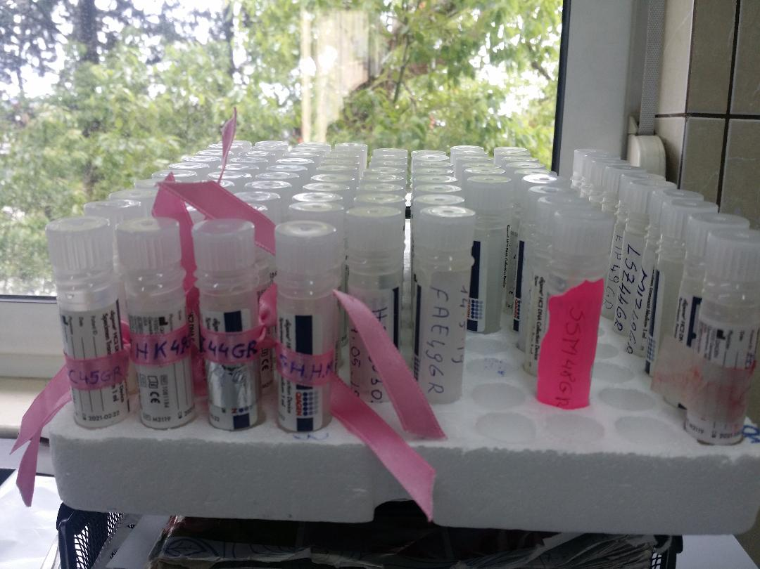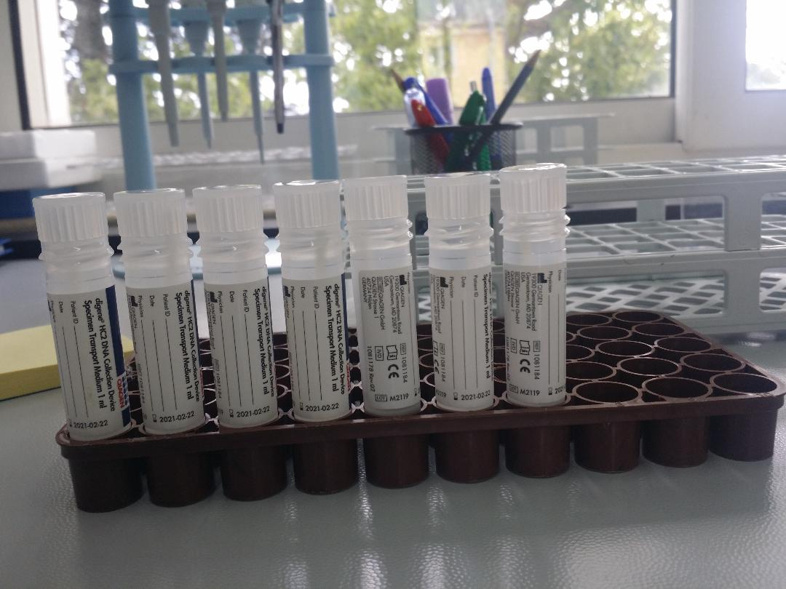

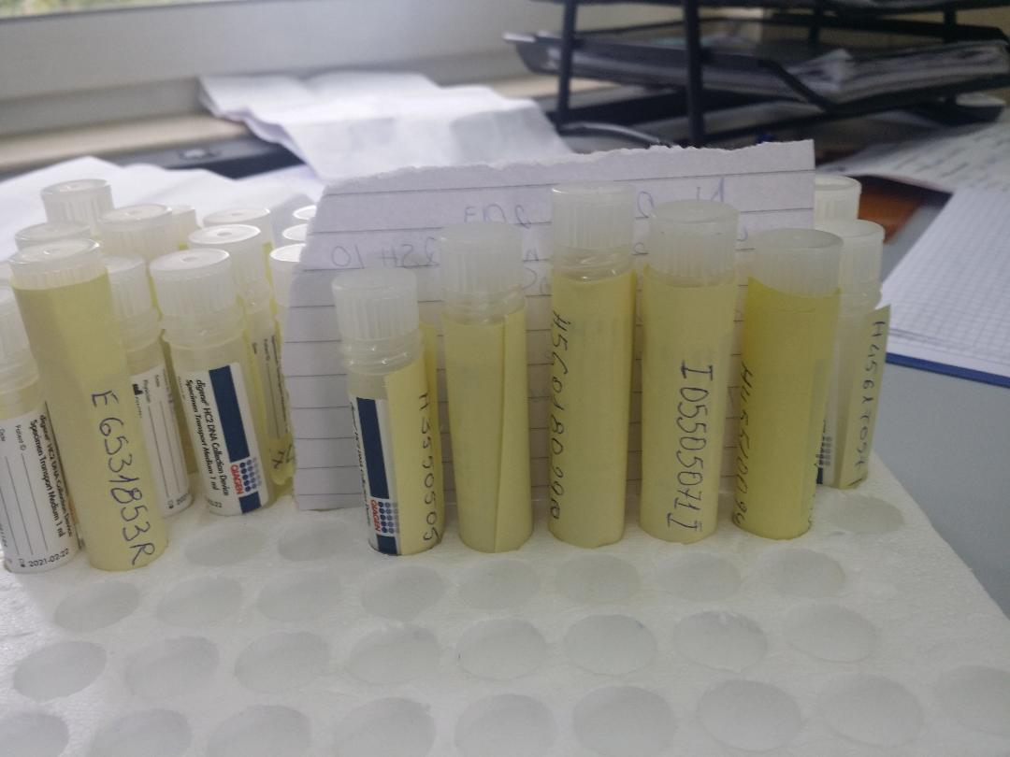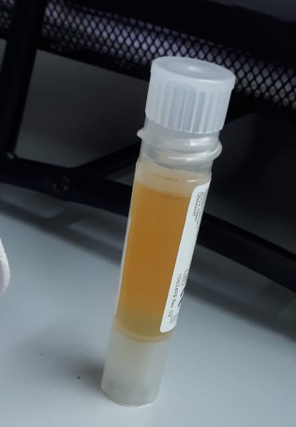

Samples transportation
Transporting samples to the lab and, getting lab results has been a challenge during this year. Family doctors and nurses are trained on process details. However, a lot of samples have arrived in the lab out of the time limit (3 weeks) set in the protocol (3, 5 or 6 months later from the time of collection).
Samples transport was carried out by circumstantial HCC means, often incorrectly and chaotically as shown in the following pictures. In the future, it is recommended the purchase of appropriated racks and boxes from the Local Health Care Units budget,.

Samples registration
Samples registration in the lab is done manually, a method that takes a long time and is unsuitable for a screening program where the workflow is very high. It is recommended the use of a barcode-based registration software.
Samples storage
After registration, the samples are stored at -20 ° C until the testing process. Specimen storage concerns were discussed above.
HPV testing and reporting of results
HPV testing is performed with FDA approved Digene Rapid Capture System (Qiagen) based on HC2 technology. The system analyzes 352 samples in 4.5 hours.
Each tested woman has received the result within three weeks of the sample collection process. The result is given by a manually written form. The test results are taken from LBM by a HCC authorized person or sent by mail. It will be much more efficient and faster to automatically refer the results from the central laboratory to the HCC (family doctor) through an computational information system.
Information system
Very basic information systems exist both in the HPV laboratory and in health care centers but they are not linked to each other and, they do not use the same software.
An Information System, accessible to all actors and structures within the NCCSP, is one of the most important challenges for the laboratory, as well as for all components of the NCCSP. This system should collect information at the local health care site using women forms or registers and, should then flow to central laboratory and to program coordinator, for monitoring women’s test results and the program’s coverage goals. The information system could be used to evaluate HPV test quality also.
Quality assurance system
Establishing a quality assurance system is crucial for the HPV test laboratory , which should be register to an internationally recognized validation/quality assurance scheme (e.g., CAP, NEQAS, QCMD).

Annex 1
Comments from Hr HPV positive women participating in the evaluation survey
- Testi ishte shume I dobishem per mua
- Rikontroll pas 3-muajsh
- U Shqetesova shume nga Rezultati I HPV por u qetesova pasi kolposkopia me doli negative
- Gjinekologia rikontroll pas 3 - muajesh
- U tremba shume nga pergjigjja sa kam frike te shkoj te bej kolposkopine
- E lumtur qe po I kushtohet rendesi problemeve te grave dhe qe motivohen te kontrollohen.
- Kam permiresime
- Gjate plotesimin te pyetesorit erdhi burri I cili nuk e lejoi gruan te vazhdonte
- Te behen depistime dhe per mosha te tjera grash
- Jam e kenaqur qe nga fillimi I ketij testimi deri ne fund. Ju falenderoj!
- Kontrolle te tjera te metejshme
- Kam permiresime
- te vazhdoj perseri dhe te na thone ku te shkojm pas rezultatit pozitiv
- HPV duhet te behet ne cdo grua pasi eshte nje ekzaminim shume I thjeshte dhe mund te na shpetoje jeten
- Te ofrohen analiza te tjera sic jane markuset tumorale falas ne Q.Sh
- Te behen sa me shpesh keto testime.
- Te ofrohen analiza te tjera sic jane markuset tumorale falas ne Q.Sh
- jam shume e kenaqur nga sherbimi shendetesor
- Jam Shum e kenaqur me testimin falas e mbi te gjitha qe na ofrohet ne shtepit tona. Ju falenderoj!
- te behet perseri
- Deshiroj testime te metejshme
- jam e kenaqur nga sherbimi shendetesor
- Skam vendosur akoma se ku do ta kryej Kolposkopine
- Mbas kolpskopis me doli negative pergjigja
- Pas rezultatit pozitiv te dime ku te shkojme
- Planifikoj te shkoj se shpejti ne Greqi te bej egzaminimet e nevojshme
- Jam Shume e kenaqur me sherbimin e ofruar falas. Shpresoj te riofrohet serish.
- Te ofrohen depistime dhe per mosha te tjera grash
- Te keshillohemi me shume pas rezultatit
- U Shqetesova shume nga Rezultati I HPV por u qetesova pasi kolposkopia me doli negative
- jam shume e kenaqur
- Jam shum e kenaqur si me testimin ashtu dhe me stafin mjekesor qe me ka sherbyer. Ju faleminderit!
- Kontrolle te metejshme te gjenekologu ne Tirane
- Te rekomandohet nje vend specifik ku te shkojme mos qe mos te perfundojm te privati qe para se te kryej kolposkopin te bene testime te tjera dhe thote shikojm per kolposkopin
- Testi I HPV ishte I sakte pasi edhe kolposkopia me doli pozitive.
- Te behet me shpesh dhe pa kufi moshe, te perfshihen edhe mosha te ndryshme.
- Ju falenderoj per mundesin qe na keni dhene duke na ofruar testimin falas.
- Mbas kolpskopis me doli negative pergjigja
- Jam shume e kenaqurme kete depsitim dhe me sherbimin mjekesor si nga paresori ashtu dhe nga mjeket specialist. Edhe pas Pap Testit dola negative jam e qete dhe vazhdoj nje jete normale por do bej rikontrolle te herepashershme, prandaj ju lutem na riofroni testimin serish falas.
- Faleminderit me sherbeu per diagnostikimin e hershem te kancerit
- Mbas kolpskopis me doli negative pergjigja
- Kam permiresime
- jam shume e kenaqur nga sherbimi shendetesor
- Te riofrohet sherbimi I testimit.
- te behet per me shume gra
- Une konfirmova problemin qe isha ne djeni ,te ndihmohen dhe te tjerat si une
- Te mos zgjatet kaq shume koha e pergjigjes se testimit te HPV
- Nuk ka bere asnje lloj kontrolli qe pas referimit per kolposkopi
- Ju falenderoj per kete mundesi qe na keni ofruar me u testu falas. Jam shum e kenaqur.
- Nuk ka bere asnje lloj kontrolli qe pas referimit per kolposkopi
- Pap testi me doli Negativ dhe gjinekologu me rekomandoi rikontroll per 3 muaj
- Ndihem mire pas trajtimit
- Kolposkopia ne maternitetin e Korces nuk funksionon dhe detyrohemi te shkojme ne privat.
- Shpresoj qe te ofrohen edhe testimet e tjera po falas sikuse dhe testimi I HPV-se.
- Fushate sensibilizuese me te shpeshta
- E perjetova shume keq pergjigjen dhe kam frike te bej kolposkopine
- Kontrolle te tjera te metejshme te gjenekologu ne Tr
- Jam e kenaqeur me testimin.
- Pergjigja e Kolposkopise me doli negative
- Jam e kenaqur e kenaqur me sherbimin be pergjihesi
- Kontrolle te tjera te metejshme
- Nuk kam ndonje koment ne lidhje me permiresimin, vetem falenderim per mundesin e testimit falas.
- Te behem sa me shpesh kontrolle te ofruara nga Q.Sh.
- Ndjekja te mos lihet deri tek rezultati
- Te behem sa me shpesh kontrolle te ofruara nga Q.Sh dhe informimi I grave ne lidhje me shendetin
- Te behet per te tjera gra
- Te ofrohen analiza te tjera sic jane markuset tumorale falas ne Q.Sh
- Asgje e lash me kaq
- Te behem sa me shpesh kontrolle te ofruara nga Q.Sh.
- Kontrolle te metejshme te ginekologu
- Duhet te funksionoje Kolposkopia ne qytetin e Korces
- Kam shume frike mos me zhvillohet kancer
- Ju falenderoj per mundesin qe na ofruat kete testim falas.
- Shpresoj te ofrohen falas edhe testimet e tjera afer zones ku ne banojme. Jam shum e kenaqur me sherbimin.
- Tebehet per me shume gra.Faleminderit
- Jam e kenaqur me sherbimin e personilit mjekesor, ishin nje numer I kufizuarr grash, ndaj te shtohet numri I grave per testim.
- Testimi ishte shume I mire e duhet te vazhdoje te behet per te gjitha grate
- Kolposkopia ne maternitetin e Korces nuk funksionon dhe detyrohemi te shkojme ne privat.
- Te informohet popullata per parandalimin e kesaj semundjeje te rrezikshme.
- Mbas kolpskopis me doli negative pergjigja
- Te behen sa me shume testime te tilla me qellim qe te parandalohet semundja.
- Kontrolle te tjera te metejshme te gjenekologu ne Tirane
- Te ofrohen sa me shume nga Q.Sh depistime
- Nuk kam besim tek testi
- Nuk ka vend per komente mbi perpmiresimin, vetem shpresoj qe te ripofrohet si sherbim.
- Dihet nga te afermit qe ka dal pozitiv per kancer dhe po trajtohet jashte vendit (itali)
- Temos lihet me kaq
- Te kemi sa me shume informacion me ecurine dhe ndjekjen
- Jam shum e kenaqur me testimin dhe komplet sherbimin. Ju falenderoj per mundesin qe na keni ofruar.
- Nuk ka vend per permiresim. Thjesht ju falenderoj per mundesin qe na dhate duke kryer kete testim falas dhe afer shtepis tone.
- Te ndihmohemi pas marjes se rezultatit dhe te behet prape per te tjera
- Nuk ka vend per permiresim, jam shume e kenaqur me testimin e ofruar falas. Shpresoj te vazhdoj cdo vit edhe me moshat e tjera.
- Te realizohen depitime ne Q.Sh
- Planifikoj te shkoj se shpejti ne Greqi ose Maqedoni te bej egzaminimet e nevojshme
- Te dime ku te shkojm dhe te behet me shume per personat me probleme ekonomike si une

Annex 2
SKEDA PERSONALE E GRUAS
*Kodi i gruas do të jetë i përbërë nga:

Shkronja e parë e Emrit……………….(Ana)..............A

Shkronja e parë e emrit të Babait…..…(Lin)…….....L

Shkronja e parë e Mbiemrit…………...(Bushi)……...B

Mosha………………………………………..…………………….45

Inicialet e rrethit………………….......(Tiranë)………...TR

ALB45TR
Annex 3

Programi Kombetar I Depistimit te kancerit te qafes se mitres
PYETESOR MBI VLERESIMIN E PROGRAMIT
VETEM PER GRATE QE KANE REZULTUAR POZITIVE NE TESTIN PRIMAR TE Hr-HPV
Data do te plotesohet nga sherbimi shendetesor
Data e plotesimit_____________________________________________________________________________
Qendra shendetesore ku gruaja eshte testuar _____________________________________________________
Rrethi______________________________________________________________________________________

E dashur pjesemarrese,
Me qellim qe te permiresojme sherbimet e parandalimit te kancerit te qafes se mitres, Instituti i Shendetit Publik, kryen kete vleresim per te kuptuar me mire mbarevajtjen e programit dhe efikasitetin e sherbimeve gjate vitit te pare te zbatimit te tij.
Ky pyetesor eshte anonim (nuk duhet emri juaj) dhe pergjigjet tuaja do te perdoren vetem vetem per qellime studimi. Ky vleresim do te marri 1-20 minuta per t’u plotesuar.
Ju faleminderit per bashkepunimin ne kete vleresim!

Te dhena te pergjitheshme
Te dhena demografike
Mosha □ □ Vite | Shkollimi □ Nuk ka perfunduar 8-vjecare  □ Ka perfunduar 8-vjecare  □ Ka perfunduar te mesme □ ka perfunduar universitet
Statusi civil □ Beqar  □ Martuar  □ Divorcuar  □ E ve | Punesimi □ Punesim sektori publik  □ Punesim sektori privat  □ Pune pa pagese shtepi  □ Pa pune
Semundje kronike □ Po □ Jo  Nese po cila __________________ | Distanca nga □□ Ne minuta  qendra  shendetesore

Te dhena mbi pervojen lidhur me testimin per HPV ne qendren shendetsore

1. A kishit degjuar per parandalimin e kancerit te qafes se mitres para testimit ? □ Po □ Jo

2. A kishit degjuar per virusin e Papilomes njerezore (HPV) para testimit ? □ Po □ Jo

3. Kishit kryer me pare nje ekzaminim per qafen e mitres? □ Pap test
□ HPV
□ Ekzaminim gjinekologjik

4. Nese po, para sa kohesh □ □ Muaj

4. Kush ju informoi per te shkuar per kryerjen e testimit? □ Mjekja
□ Infermierja
□ Tjeter

5. Si ju informuan per te shkuar per kryerjen e testimit? □ Telefon
□ Vizite ne shtepi
□ Gjate nje vizite ne qender
□ Nepermjet nje te afermi
□ Tjeter __________________

6. Pas sa kohesh nga momenti i informimit shkuat per testim ? □ □ Dite

7. Kur shkuat per testim kush ju priti dhe keshilloi ? □ Mjekja
□ Infermierja
□ Tjeter ___________________

8.1 Sa kohe zgjati instruksioni/keshillimi para testimit? □ □ Minuta
8.2 Sa kohe zgjati instruksioni/keshillimi pas testimit? □ □ Minuta

9. A ju keshilluan mbi keto ceshtje ? □ Si te merrni mostren vaginale
□ Per se sherben testimi
□ Tjeter ___________________

10. I kerkuat mjekut qe tua merrte ai mostren vaginale ? □ Po □ Jo

11. Nese jo, ku vendoset ta merni vete mostren vaginale ? □ Ne qendren shendetsore (nje dhome)
□ Ne qendren Shendetsore (tualet)
□ Ne shtepine tuaj
□ Tjeter ___________________

12. Nese e moret mostren ne qendren shendetesore,
si ishin kushtet. Nga 1 (keq) ne 5 (mire) ? □ Vendos nje numer nga 1 ne 5

13. Nese e moret mostren ne shtepi,
Pas sa ditesh e dorezuat ne qendren shendetsore ? □ □ Dite

14. Ishte marrja e mostres e thjeshte? □ Shume □ Pak □ Aspak

15. Ishte marrja e mostres e dhimbshme? □ Aspak □ Pak □ Shume

Te dhena mbi marrjen e rezultatit

16. Pas sa kohesh morret pergjigje mbi rezultatet e tesimit ? □ □ Minuta

17. Ne c’menyre u kontaktuat per kete ? □ Telefon
□ Vizite ne shtepi
□ Gjate nje vizite ne qender
□ Nepermjet nje te afermi
□ Tjeter __________________

18. Pas sa kohesh nga informimi shkuat per rezultatin? □ □ Dite

19. Kur shkuat per rezultatin kush ju priti dhe keshilloi ? □ Mjekja
□ Infermierja
□ Tjeter ___________________

20. Sa kohe zgjati keshillimi mbi rekomandimet? □ □ Minuta

21. A ju keshilluan mbi keto ceshtje ? □ Te shkoni per kolposkopi te gjinekologu
□ Informacion mbi infeksionin nga HPV
□ Informacion mbi spitalin ku te shkoni
□ Informacion mbi kolposkopine
□ Informacion mbi lezionet gjinekologjike
□ Te drejten per intimitet mbi rezultatin
□ Tjeter ___________________

22. Ne opinionin tuaj, ishte keshillimi i mjaftueshem? □ Po plotesisht □ Deri diku □ Jo

22. A folet mbi rezultatet me persona te tjere? □ Po □ Jo

23. Nese po me cilin? □ Bashkeshortin
□ Prinderit/motrat/vellezerit
□ Shoqe/miq
□ Tjeter ___________________

24. Patet shqetesime emocionionale lidhur me rezultatin? □ Po □ Jo

25. Nese po, rendisni nga 1 (pak) ne 5 (shume) □ Vendos nje numer nga 1 ne 5

Te dhena mbi ekzaminime te metejshme

26. E kryet kolposkopine pas informimit mbi infeksionin HPV? □ Po □ Jo

27. Nese jo per c’arsye? □ Planifikoj te shkoj se shpejti
□ Skam kohe. E zene me pune
□ Nuk ja vlen. Nuk besoj te spitalet
□ Nuk e di ku te shkoj
□ Eshte shume larg
□ Kushton shume
□ Kam frike
□ Nuk me lejojne
□ Tjeter ___________________

28. Nese po ku e kryet? □ Spitali Koco Gliozheni (Tirane)
□ Mbreteresha Geraldine (Tirane)
□ Spital Rajonal ______________
□ Spital privat________________
□ Jashte shtetit ______________
□ Tjeter ____________________

29. Pas sa kohesh nga rekomandimi shkuat per kolposkopi? □ □ Dite

30. Cili ishte rezultati i kolposkopise? □ Negativ
□ Pozitiv (lezione intraepiteliale)
□ Nuk e di

31. Nese mundeni, vendosni rezultatin specifik. ______________________________

32. A ju keshilloi gjinekologjja mbi keto ceshtje ? □ Lezionet gjinekologjike ne kolposkopi
□ Para-kancerin dhe kancerin
□ Ku te kryeni teste te metejshme
□ Monitorimi afatgjate shume vjecar
□ Kostot e testimeve
□ Tjeter _____________________

33. Nese negativ, ju keshilluan te riktheheni per monitorim? □ Po □ Jo

34. Nese po pas sa kohesh ? □ □ Vjet □ □ Muaj

35. Ju keshilloi gjinekologjja testime/analiza te tjera? □ Po □ Jo

36. Nese po, cilin? □ Pap-test/citologji
□ Nje test HPV tjeter (per tipizim)
□ Biopsi
□ Tjeter ___________________

37. Sa kohe zgjati ekzaminimi gjinekologjik/ rekomandimet? □ □ Minuta

38. Sa kohe zgjati pritja para takimit me mjekun? □ □ Minuta

39. Kryet testime te tjera te rekomanduara nga gjinekologu? □ Po □ Jo

40. Nese po, cilin? □ Pap-test/citologji
□ Nje test HPV tjeter (per tipizim)
□ Biopsi
□ Tjeter ___________________

41. Nese jo, per c’arsye ? □ Planifikoj te shkoj se shpejti
□ Nuk e di ku te shkoj
□ Kushton shume
□ Kam frike
□ Tjeter ___________________

42. Ju kane rekomanduar trajtim/mjekim? □ Po □ Jo

43. Nese po cilin? ___________________________

44. Vleresoni sherbimin gjinekologjik dhe testimet e tjera
me nje numer nga 1 (keq) ne 5 (mire) □ Vendos nje numer nga 1 ne 5

45. Komente, propozime per permiresim
_____________________________________________________________________________________________________________________________________________________________________________________________________________________________________________________________________

Ju falemnderit.

Annex 4
Pyetje per informuesit kyc
Organizimi
A gjurmon sistemi grate qe kerkojne follow-up
Pengesa finaciare, gjeografike dhe administrative lidhur me depistimin, diagnozen dhe trajtimin
Cilesia e grumbullimit te mostrave dhe transporti
Cilet jane anet e forta te programit. Cilat jane pikat e dobeta te programit

Aksesi ne sistem. Ndjekja e metejshme e grave pozitive
Kush kryen sherbimet e depistimit primar,
Si u identifikuan dhe u ftuan grate per depistim,
Si mund te permiresohet identifikimi i popullates target
Ku kryhet testimi, ne QSH, shtepi.
A jane trajnuar personeli shendetesor
Si eshte cilesia e ekzaminimit gjinekologjik, si mund te permiresohet
Sa eshte mesatarja ne kohe per kthimin e pergjegjeve te testit,
Kush i fton grate per rezultatet dhe ja komunikon pergjigjet, ai merr gruaja pergjigjet, dhe a keshillohet per me tej
Cilesia e grumbullimit te mostrave dhe cilesia e informacionit
Probleme lidhur me kodet ne kite, shenimi mbi to, skedat
Sistemi i nformacionit
Si finksionon kodi identifkues
Si grumbullohet informacioni per depistim dhe follow up
Pengesat, sfidat, e monitorimit të të dhënave
Konkluzione/ komente/rekomandime

